# URLs

* AP_GD / https://drive.google.com/drive/folders/1I0bn93wzhYq_nO4U9Jc2PvDiOxzEQ4mL
* [https://developers.google.com/public-data/docs/examples /](https://developers.google.com/public-data/docs/examples%20/)
* <https://github.com/google/dspl>
* <https://materializecss.com/>
* <https://www.youtube.com/watch?v=_zPNLidkNYk> > javascript course
* <https://developers.google.com/apps-script/guides/html/reference/run#index.html_1>
* <https://spreadsheet.dev/google-apps-script-tutorial>

## next

<https://www.youtube.com/watch?v=PJVivAZKqpM&list=PLe_F6wC3FvdolT54Pmi2Ht9_08kP5fFFQ>

# Google Sheets Userform - Level 2

<https://www.youtube.com/watch?v=VzUDw7O8yhE&list=PLv9Pf9aNgemuzTNWeHd8HziGVNzSlWACh>

## #Google Sheets - UserForm Web App using HTML5 & Bootstrap 4

## Google Sheets UserForm - Send Data from Form to Spreadsheet

getbootstrap.com

apps script project name UF Level 2

create uform.html for user interface

* bootstrap – starter template – copy paste to uform
* we will work on <body> area

### General Info

* Create Menu – loadUserForms.gs
* By Clicking the Menu, load Form in the side fo the gsheet
* Design a user input form – uform.html
  + onClick of the button, collect the form input and send to server side function
* loadUserForms.gs
  + get the data from uform.html onclick event, the append the data into gsheet.

### loadUserForm.gs

function loadForm() {

  const htmlForSidebar = HtmlService.createTemplateFromFile("uform");

  const htmlOutput = htmlForSidebar.evaluate();

  const ui = SpreadsheetApp.getUi();

  ui.showSidebar(htmlOutput);

}

function createMenu(){

  const ui = SpreadsheetApp.getUi();

  const menu = ui.createMenu("My Forms");

  menu.addItem("ShowUserForm", "loadForm");

  menu.addToUi();

}

function onOpen(){

  createMenu();

}

### uform.html

<!doctype html>

<html lang="en">

  <head>

    <!-- Required meta tags -->

    <meta charset="utf-8">

    <meta name="viewport" content="width=device-width, initial-scale=1">

    <!-- Bootstrap CSS -->

    <link href="https://cdn.jsdelivr.net/npm/bootstrap@5.1.3/dist/css/bootstrap.min.css" rel="stylesheet" integrity="sha384-1BmE4kWBq78iYhFldvKuhfTAU6auU8tT94WrHftjDbrCEXSU1oBoqyl2QvZ6jIW3" crossorigin="anonymous">

    <title>Hello, world!</title>

  </head>

  <body>

    <div>

      <div class="mb-3">

        <label for="item-name" class="form-label">Item Name</label>

        <input type="text" class="form-control" id="item-name" aria-describedby="emailHelp">

        <div id="emailHelp" class="form-text">We'll never share your email with anyone else.</div>

      </div>

      <div class="mb-3">

        <label for="qty-received" class="form-label">Qty Received</label>

        <input type="text" class="form-control" id="qty-received">

      </div>

      <button class="btn btn-primary" id="mainButton">Add</button>

    </div>

    <!-- Optional JavaScript; choose one of the two! -->

    <!-- Option 1: Bootstrap Bundle with Popper -->

    <script src="https://cdn.jsdelivr.net/npm/bootstrap@5.1.3/dist/js/bootstrap.bundle.min.js" integrity="sha384-ka7Sk0Gln4gmtz2MlQnikT1wXgYsOg+OMhuP+IlRH9sENBO0LRn5q+8nbTov4+1p" crossorigin="anonymous"></script>

    <!-- Option 2: Separate Popper and Bootstrap JS -->

    <!--

    <script src="https://cdn.jsdelivr.net/npm/@popperjs/core@2.10.2/dist/umd/popper.min.js" integrity="sha384-7+zCNj/IqJ95wo16oMtfsKbZ9ccEh31eOz1HGyDuCQ6wgnyJNSYdrPa03rtR1zdB" crossorigin="anonymous"></script>

    <script src="https://cdn.jsdelivr.net/npm/bootstrap@5.1.3/dist/js/bootstrap.min.js" integrity="sha384-QJHtvGhmr9XOIpI6YVutG+2QOK9T+ZnN4kzFN1RtK3zEFEIsxhlmWl5/YESvpZ13" crossorigin="anonymous"></script>

    -->

<script>

  function afterButtonClicked(){

    var item = document.getElementById("item-name");

    var qty = document.getElementById("qty-received");

    var rowData = {item:item.value, qty:qty.value};

    google.script.run.addNewRow(rowData);

  }

  document.getElementById("mainButton").addEventListener("click",afterButtonClicked);

</script>

  </body>

</html>

### funcs.gs

function addNewRow(rowData) {

  const currentDate = new Date();

  const ss = SpreadsheetApp.getActiveSpreadsheet();

  const ws = ss.getSheetByName("Results");

  ws.appendRow([rowData.item,rowData.qty,currentDate]);

}

## Google Sheets Userform - Add a Dropdown

### General

* Add container for our input form elements
  + <https://getbootstrap.com/docs/5.1/layout/containers/> - default container
* Add drop down
  + <https://getbootstrap.com/docs/5.1/forms/select/#default>

## Google Sheets Userform - Dependent Dropdown in a Web App

## Google Sheets Userform - Add Basic Form Validation

## Google Sheets Userform - Custom Form Validation

## Google Sheets Userform - Loading... Bootstrap Spinner

## Google Sheets Userform - Cascading Dropdown - 3 Levels

## Google Sheets Userform - Server Side (Back-End) vs Front-End, google.script.run Apps Script

## Google Sheets Userform - Load Matching Data from Spreadsheet

## Google Sheets Userform - Fancy Checkboxes, Bootstrap Toggle

## Google Sheets Userform - Conditional Multi Input Boxes

## Google Sheets Userform - Data & Form in Separate Spreadsheets

# ???Userform Level 3 Series - Google Sheets CRUD

<https://www.youtube.com/playlist?list=PLv9Pf9aNgemvM36efLpaHxbkZTGp2pfhx>

<https://www.youtube.com/watch?v=Vx8Da4bB620> – John

<https://www.youtube.com/watch?v=ctjyyL--qdA> – code with curt

<https://www.youtube.com/watch?v=MC5bs6xNpiM>

## Web App - Google Sheets CRUD - Part 1 - Load Views 36.48

* Google Sheet + Bootstrap framework + javascript code
* <https://getbootstrap.com/>
  + get Started - Starter template – copy and paste it in main.html
  + main.html, just above the </body> add script tag
* AP_GD/CRUD - Learn Google Spreadsheets/
* Tab control created – Home, Add, Edit template created

### code.gs

function loadMainForm() {

  const htmlServ = HtmlService.createTemplateFromFile("main");

  const html = htmlServ.evaluate();

  html.setWidth(850).setHeight(600);

  const ui = SpreadsheetApp.getUi();

  ui.showModelessDialog(html,"Edit Customer Data");

}

function createMenu_(){

  const ui = SpreadsheetApp.getUi();

  const menu = ui.createMenu("Custom Menu");

  menu.addItem("Open Form", "loadMainForm");

  menu.addToUi();

  return true;

}

function onOpen(){

  createMenu_();

}

### main.html

<!doctype html>

<html lang="en">

  <head>

    <!-- Required meta tags -->

    <meta charset="utf-8">

    <meta name="viewport" content="width=device-width, initial-scale=1">

    <!-- Bootstrap CSS -->

    <link href="https://cdn.jsdelivr.net/npm/bootstrap@5.1.3/dist/css/bootstrap.min.css" rel="stylesheet" integrity="sha384-1BmE4kWBq78iYhFldvKuhfTAU6auU8tT94WrHftjDbrCEXSU1oBoqyl2QvZ6jIW3" crossorigin="anonymous">

  <script>

    .nav-link{

      cursor:pointer;

    }

  </script>

  </head>

  <body>

<h1>Hello, world!</h1>

<div class="container">

  <!-- Content here -->

  <ul class="nav nav-tabs">

  <li class="nav-item">

    <div class="nav-link" id="home-link">Home</div>

  </li>

  <li class="nav-item">

    <div class="nav-link" id="search-link">Search</div>

  </li>

  <li class="nav-item">

    <div class="nav-link" id="add-customer-link">Add Customer</div>

  </li>

</ul>

<div id="app"> </div>

</div>

    <!-- Optional JavaScript; choose one of the two! -->

    <!-- Option 1: Bootstrap Bundle with Popper -->

    <script src="https://cdn.jsdelivr.net/npm/bootstrap@5.1.3/dist/js/bootstrap.bundle.min.js" integrity="sha384-ka7Sk0Gln4gmtz2MlQnikT1wXgYsOg+OMhuP+IlRH9sENBO0LRn5q+8nbTov4+1p" crossorigin="anonymous"></script>

    <!-- Option 2: Separate Popper and Bootstrap JS -->

    <!--

    <script src="https://cdn.jsdelivr.net/npm/@popperjs/core@2.10.2/dist/umd/popper.min.js" integrity="sha384-7+zCNj/IqJ95wo16oMtfsKbZ9ccEh31eOz1HGyDuCQ6wgnyJNSYdrPa03rtR1zdB" crossorigin="anonymous"></script>

    <script src="https://cdn.jsdelivr.net/npm/bootstrap@5.1.3/dist/js/bootstrap.min.js" integrity="sha384-QJHtvGhmr9XOIpI6YVutG+2QOK9T+ZnN4kzFN1RtK3zEFEIsxhlmWl5/YESvpZ13" crossorigin="anonymous"></script>

    -->

    <script>

      function loadView(options){

        var id = typeof options.id === "undefined" ? "app" : options.id;

        var cb = typeof options.callback === "undefined" ? function(){} : options.callback;

        google.script.run.withSuccessHandler(function(html){

         document.getElementById(id).innerHTML = html;

         typeof options.params === "undefined" ? cb(): cb(options.params);

        })[options.func]();

      }

      function loadSearchView(){

        loadView({func: "loadSearchView"});

      }

      function loadAddCustomerView(){

        loadView({func: "loadAddCustomersView"});

      }

      function loadEditCustomerView(){

        loadView({func: "loadEditCustomersView"});

      }

      document.getElementById("search-link").addEventListener("click",loadSearchView);

      document.getElementById("add-customer-link").addEventListener("click",loadAddCustomerView);

      document.getElementById("home-link").addEventListener("click",loadEditCustomerView);

    </script>

  </body>

</html>

### search.html

<h1>Search</h1>

<div class="mb-3">

  <input type="text" class="form-control" id="SearchInput" placeholder="Searach ... ">

</div>

<table class="table table-hover">

 <thead>

    <tr>

      <th scope="col">#</th>

      <th scope="col">First</th>

      <th scope="col">Last</th>

      <th scope="col"></th>

      <th scope="col"></th>

    </tr>

  </thead>

  <tbody>

    <tr>

      <th scope="row">1</th>

      <td>Mark</td>

      <td>Otto</td>

      <td>@mdo</td>

      <td><button type="button" class="btn btn-dark">Edit</button></td>

      <td><button type="button" class="btn btn-dark">Delete</button></td>

    </tr>

</table>

### addcustomer.html

<h1>Add a Customer</h1>

<div class="add-customer-form">

  <div class="mb-3">

    <label for="first-name" class="form-label">First Name</label>

    <input type="email" class="form-control" id="first-name" >

  </div>

  <div class="mb-3">

    <label for="last-name" class="form-label">Last Name</label>

    <input type="email" class="form-control" id="last-name" >

  </div>

    <div class="mb-3">

    <label for="phone-number" class="form-label">Phone Number:</label>

    <input type="email" class="form-control" id="phone-number" >

  </div>

  <button class="btn btn-primary">Add Customer</button>

</div>

### loadPartials.gs

function loadPartialHTML_(partial) {

  const htmlServ = HtmlService.createTemplateFromFile(partial);

  return htmlServ.evaluate().getContent();

}

 function loadSearchView(){

   return loadPartialHTML_("search");

 }

  function loadAddCustomersView(){

   return loadPartialHTML_("addcustomer");

 }

   function loadEditCustomersView(){

   return loadPartialHTML_("editcustomer");

 }

### editcustomer.html

<h1>Edit Customer</h1>

<div class="edit-customer-form">

  <div class="mb-3">

    <label for="custoerID" class="form-label">Customer ID</label>

    <input type="text" class="form-control" id="custoerID" >

  </div>

    <div class="mb-3">

    <label for="first-name" class="form-label">First Name</label>

    <input type="text" class="form-control" id="first-name" >

  </div>

  <div class="mb-3">

    <label for="last-name" class="form-label">Last Name</label>

    <input type="email" class="form-control" id="last-name" >

  </div>

    <div class="mb-3">

    <label for="phone-number" class="form-label">Phone Number:</label>

    <input type="email" class="form-control" id="phone-number" >

  </div>

  <button class="btn btn-primary">Submit</button>

  <button class="btn btn-primary">Cancel</button>

</div>

## Web App - Google Sheets CRUD - Part 2 - Search Data Table 29:52

* Search functionality implementation
  + load the data into memory
  + serverSideFuncs.gs created for this
    - getDataForSearch() – call this function from main to load into memory

Learn Google Spreadsheets

3

27:11

NOW PLAYING

Web App - Google Sheets CRUD - Part 3 - Delete Rows from Spreadsheet

Learn Google Spreadsheets

4

32:32

NOW PLAYING

Web App - Google Sheets CRUD - Part 4 - Edit Data in Google Sheets

Learn Google Spreadsheets

5

25:01

NOW PLAYING

Web App - Google Sheets CRUD - Part 5 - Add Data

Learn Google Spreadsheets

6

28:49

NOW PLAYING

Web App - Google Sheets CRUD - Part 6 - Design Better User Experience

Learn Google Spreadsheets

# # %Google Apps Script - Web App Tutorial

## #Google Sheets Web App Example - Google Apps Script Web App Tutorial - Part 1 31:41

* connect “Google apps scripts” app into our drive
* 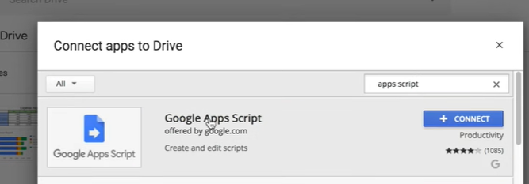
* Goto GDrive – RtClick – Google Apps Script - Project Name – Basic WebApp
* Web url starting pont is > function doGet() > return HTML
* Use Test Deployment in development phase

### code.gs

function doGet(e){

  //return HtmlService.createHtmlOutput("Hello");

  Logger.log(e);

  return  HtmlService.createHtmlOutputFromFile("page");

}

function userClicked(uname){

  var url = "https://docs.google.com/spreadsheets/d/1atiwcUuUIeGBtZKw54R-IkVp5zTHS6AO8p-lyKEoO2Y/edit#gid=0"

 // var url = "https://docs.google.com/spreadsheets/d/1atiwcUuUIeGBtZKw54R-IkVp5zTHS6AO8p-lyKEoO2Y/edit?usp=sharing"

  var ss = SpreadsheetApp.openByUrl(url);

  var ws = ss.getSheetByName("Data");

  ws.appendRow([uname, new Date()]);

  //Logger.log(uname + " clicked the button");

}

### page.html – create new html file – name it as page

<!DOCTYPE html>

<html>

  <head>

    <base target="_top">

  </head>

  <body>

    <h1>Page html </h1>

    <label>Name: </label><input type="text" id="username">

    <button id=btnSubmit>Run It</button>

    <script>

      document.getElementById("btnSubmit").addEventListener("click",doStuff);

      function doStuff(){

        var uname = document.getElementById("username").value;

        google.script.run.userClicked(uname);

        document.getElementById("username").value = "";

      }

    </script>

  </body>

</html>

Click Deploy – Select Type as Web App

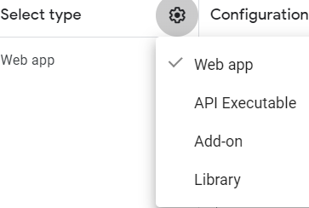

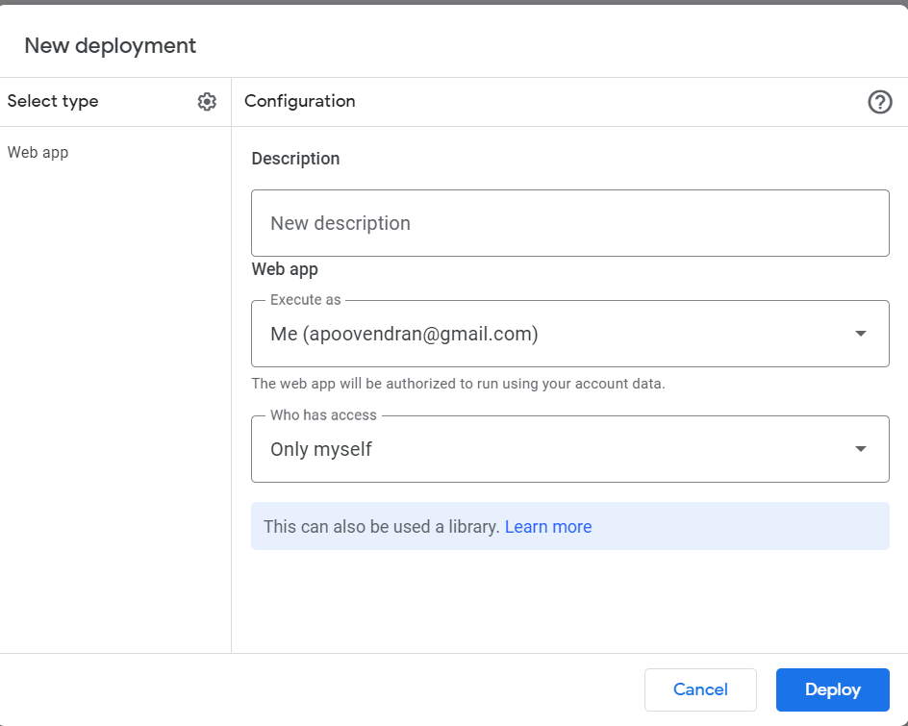

Deploy – and use the url to see the page

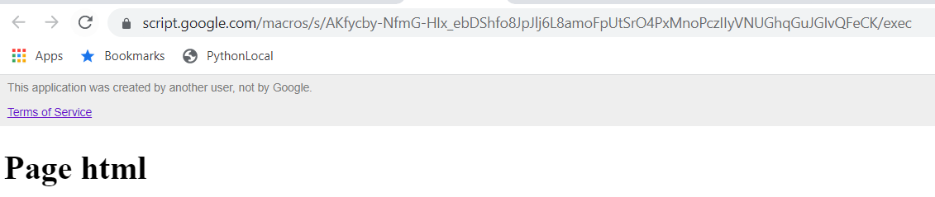

we can check by adding at the end as querystring ?name=poov

see left Icons – Executions – it will show execution history with Logs

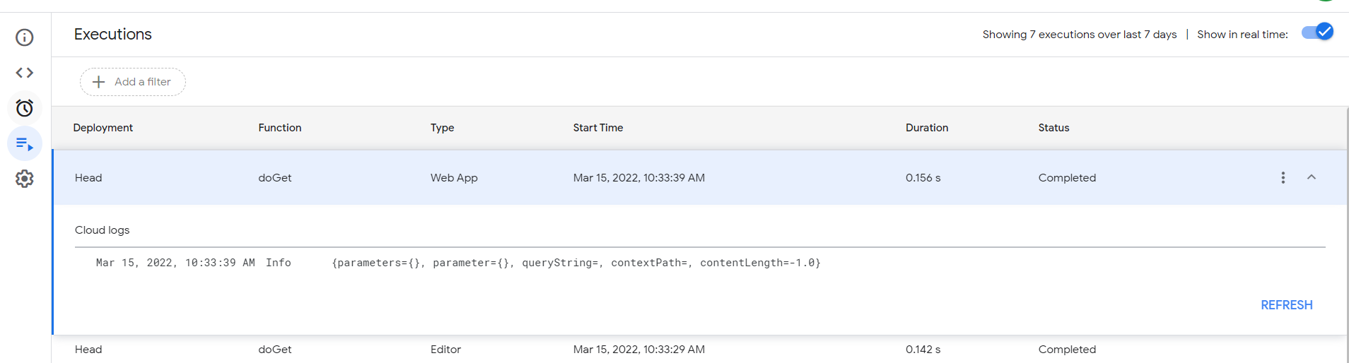

## #Template Partials & Passing Objects - Google Apps Script Web App Tutorial - Part 2 17:45

### page.html – before separating script and style

<!DOCTYPE html>

<html>

  <head>

    <base target="_top">

    <style>

        .form-row{

          margin-bottom:15px;

        }

    </style>

  </head>

  <body>

    <h1>Page Heading html </h1>

    <div class="form-row">

    <label>First Name: </label><input type="text" id="fn">

    </div>

    <div class="form-row">

    <label>Last Name: </label><input type="text" id="ln">

    </div>

    <div class="form-row">

      <label>Application: </label>

      <select id="app">

        <option>Google Sheets     </option>

        <option>Excel     </option>

        <option>Numbers     </option>

      </select>

    </div>

    <div class="form-row">

      <button id=btnSubmit>Run It</button>

    </div>

    <script>

      document.getElementById("btnSubmit").addEventListener("click",doStuff);

      function doStuff(){

        var userinfo = {};

        userinfo.firstName = document.getElementById("fn").value;

        userinfo.lastName = document.getElementById("ln").value;

        userinfo.app = document.getElementById("app").value;

        google.script.run.userClicked(userinfo);

        document.getElementById("fn").value = "";

        document.getElementById("ln").value = "";

        document.getElementById("app").value = "";

      }

    </script>

  </body>

</html>

### After separation of styles and script

#### code.gs

function doGet(e){

  return  HtmlService.createTemplateFromFile("page").evaluate();

}

function userClicked(userinfo){

  var url = "https://docs.google.com/spreadsheets/d/1atiwcUuUIeGBtZKw54R-IkVp5zTHS6AO8p-lyKEoO2Y/edit#gid=0"

  var ss = SpreadsheetApp.openByUrl(url);

  var ws = ss.getSheetByName("Data");

  ws.appendRow([userinfo.firstName,userinfo.lastName,userinfo.app, new Date()]);

  //Logger.log(Session.getActiveUser().getEmail()");

}

function include(filename){

  return HtmlService.createHtmlOutputFromFile(filename).getContent();

}

#### Page.htm

<!DOCTYPE html>

<html>

  <head>

    <base target="_top">

    <?!= include("page-css"); ?>

  </head>

  <body>

    <h1>Page Heading html </h1>

    <div class="form-row">

    <label>First Name: </label><input type="text" id="fn">

    </div>

    <div class="form-row">

    <label>Last Name: </label><input type="text" id="ln">

    </div>

    <div class="form-row">

      <label>Application: </label>

      <select id="app">

        <option>Google Sheets     </option>

        <option>Excel     </option>

        <option>Numbers     </option>

      </select>

    </div>

    <div class="form-row">

      <button id=btnSubmit>Run It</button>

    </div>

    <?!= include("page-js"); ?>

  </body>

</html>

#### page-css.html

    <style>

        .form-row{

          margin-bottom:15px;

        }

    </style>

#### page-js.html

    <script>

      document.getElementById("btnSubmit").addEventListener("click",doStuff);

      function doStuff(){

        var userinfo = {};

        userinfo.firstName = document.getElementById("fn").value;

        userinfo.lastName = document.getElementById("ln").value;

        userinfo.app = document.getElementById("app").value;

        google.script.run.userClicked(userinfo);

        document.getElementById("fn").value = "";

        document.getElementById("ln").value = "";

        document.getElementById("app").value = "";

      }

    </script>

## #Materialize CSS UI Web App - Google Apps Script Web App Tutorial - Part 3 25:11

<https://materializecss.com/>

* getting started > CDN to implement
  + copy the css link and paste it in page.html under head section
  + copy the javascript link and paste it in
  + import google icon style in HTML Setup
* <link href="https://fonts.googleapis.com/icon?family=Material+Icons" rel="stylesheet">
* <!--Let browser know website is optimized for mobile-->
* <meta name="viewport" content="width=device-width, initial-scale=1.0"/>
* in materializecss – form – Text Input – a
* Select
* Component – Buttons

### code.gs

 function doGet(e){

  return  HtmlService.createTemplateFromFile("page").evaluate();

}

function userClicked(userinfo){

  var url = "https://docs.google.com/spreadsheets/d/1atiwcUuUIeGBtZKw54R-IkVp5zTHS6AO8p-lyKEoO2Y/edit#gid=0"

  var ss = SpreadsheetApp.openByUrl(url);

  var ws = ss.getSheetByName("Data");

  ws.appendRow([userinfo.firstName,userinfo.lastName,userinfo.app, new Date()]);

  //Logger.log(Session.getActiveUser().getEmail()");

}

function include(filename){

  return HtmlService.createHtmlOutputFromFile(filename).getContent();

}

### page.html

<!DOCTYPE html>

<!--  -->

<html>

  <head>

    <base target="_top">

      <meta name="viewport" content="width=device-width, initial-scale=1.0"/>

      <link href="https://fonts.googleapis.com/icon?family=Material+Icons" rel="stylesheet">

      <link rel="stylesheet" href="https://cdnjs.cloudflare.com/ajax/libs/materialize/1.0.0/css/materialize.min.css">

    <?!= include("page-css"); ?>

  </head>

  <body>

    <div class="container">

          <h1>Heading </h1>

      <div class="row">

        <div class="input-field col s6">

          <input id="fn" type="text" class="validate">

          <label for="fn">First Name</label>

        </div>

        <div class="input-field col s6">

          <input id="ln" type="text" class="validate">

          <label for="ln">Last Name</label>

        </div>

      </div>

      <div class="row">

        <div class="input-field col s6">

            <select  id="app">

              <option value="" disabled selected>Choose your option</option>

              <option value="Google Sheets">Google Sheets</option>

              <option value="Excel">Excel 2</option>

              <option value="Numbers">Numbers</option>

            </select>

            <label>Application:</label>

          </div>  <!-- close app  -->

      </dev>

    </div>  <!-- close container  -->

    <div class="row">

      <button id=btnSubmit class="waves-effect waves-light btn"><i class="material-icons left">cloud</i>Run It</button>

    </div>

    <script src="https://cdnjs.cloudflare.com/ajax/libs/materialize/1.0.0/js/materialize.min.js"></script>

    <?!= include("page-js"); ?>

  </body>

</html>

### page-css.html

    <style>

        .form-row{

          margin-bottom:15px;

        }

    </style>

### page-js.html

    <script>

      document.addEventListener('DOMContentLoaded', function() {

        var elems = document.querySelectorAll('select');

        var instances = M.FormSelect.init(elems);

      });

      document.getElementById("btnSubmit").addEventListener("click",doStuff);

      function doStuff(){

        var userinfo = {};

        userinfo.firstName = document.getElementById("fn").value;

        userinfo.lastName = document.getElementById("ln").value;

        userinfo.app = document.getElementById("app").value;

        google.script.run.userClicked(userinfo);

        document.getElementById("fn").value = "";

        document.getElementById("ln").value = "";

        var myApp = document.getElementById("app");

        myApp.selectedIndex = 0;

        M.FormSelect.init(myApp);

      }

    </script>

## #Web App - Load Data From Spreadsheet - Google Apps Script Web App Tutorial - Part 4 27:03

* Load option data from gsheet

<? var title = "New title"; ?>

<h1><?= title; ?></h1>

      <? var title = "<i>New title</i>"; ?>

      <h1><?!= title; ?></h1>

* + without ! the <i> will not considered as html tag. better avoid ! in javascript
* global varibale we can keep in the top of code.gs

in page.html

            <select  id="app">

              <option value="" disabled selected>Choose your option</option>

              <? for (var i=0; i<list.length; i++){ ?>

                  <option><?= list[i]; ?> </option>

              <? } ?>

            </select>

in code.gs

var url = "https://docs.google.com/spreadsheets/d/1atiwcUuUIeGBtZKw54R-IkVp5zTHS6AO8p-lyKEoO2Y/edit#gid=0"

function doGet(e){

  var ss = SpreadsheetApp.openByUrl(url);

  var ws = ss.getSheetByName("Options");

  var optCells = ws.getRange("A1").getDataRegion().getLastRow()

  var lists = ws.getRange(1,1,optCells,1).getValues();

  Logger.log(lists);// this will give array in arryays

  var list = lists.map(function(r){return r[0];});

  var tmp = HtmlService.createTemplateFromFile("page");

  tmp.list = list;

  tmp.title = "doget title";

  tmp.empname = "myname" ;

  return  tmp.evaluate();

}

### code.gs

var url = "https://docs.google.com/spreadsheets/d/1atiwcUuUIeGBtZKw54R-IkVp5zTHS6AO8p-lyKEoO2Y/edit#gid=0"

function doGet(e){

  var ss = SpreadsheetApp.openByUrl(url);

  var ws = ss.getSheetByName("Options");

  var optCells = ws.getRange("A1").getDataRegion().getLastRow()

  var lists = ws.getRange(1,1,optCells,1).getValues();

  Logger.log(lists);// this will give array in arryays

  //var list = lists.map(function(r){return r[0];});

  var htmlList = lists.map(function(r){return '<option>' + r[0] + '</option>';}).join('');

  var tmp = HtmlService.createTemplateFromFile("page");

  tmp.list = htmlList;

  tmp.title = "doget title";

  tmp.empname = "myname" ;

  return  tmp.evaluate();

}

function userClicked(userinfo){

  var ss = SpreadsheetApp.openByUrl(url);

  var ws = ss.getSheetByName("Data");

  ws.appendRow([userinfo.firstName,userinfo.lastName,userinfo.app, new Date()]);

  //Logger.log(Session.getActiveUser().getEmail()");

}

function include(filename){

  return HtmlService.createHtmlOutputFromFile(filename).getContent();

}

### page.html

<!DOCTYPE html>

<!--  -->

<html>

  <head>

    <base target="_top">

      <meta name="viewport" content="width=device-width, initial-scale=1.0"/>

      <link href="https://fonts.googleapis.com/icon?family=Material+Icons" rel="stylesheet">

      <link rel="stylesheet" href="https://cdnjs.cloudflare.com/ajax/libs/materialize/1.0.0/css/materialize.min.css">

    <?!= include("page-css"); ?>

  </head>

  <body>

    <div class="container">

      <h1><?!= title; ?></h1>

      <h1><?!= empname; ?></h1>

      <div class="row">

        <div class="input-field col s6">

          <input id="fn" type="text" class="validate">

          <label for="fn">First Name</label>

        </div>

        <div class="input-field col s6">

          <input id="ln" type="text" class="validate">

          <label for="ln">Last Name</label>

        </div>

      </div>

      <div class="row">

        <div class="input-field col s6">

            <select  id="app">

              <option value="" disabled selected>Choose your option</option>

              <?!= list; ?>

            </select>

            <label>Application:</label>

          </div>  <!-- close app  -->

      </dev>

    </div>  <!-- close container  -->

    <div class="row">

      <button id=btnSubmit class="waves-effect waves-light btn"><i class="material-icons left">cloud</i>Run It</button>

    </div>

    <script src="https://cdnjs.cloudflare.com/ajax/libs/materialize/1.0.0/js/materialize.min.js"></script>

    <?!= include("page-js"); ?>

  </body>

</html>

### page-css.html

    <style>

        .form-row{

          margin-bottom:15px;

        }

    </style>

### page-js.html

    <script>

      document.addEventListener('DOMContentLoaded', function() {

        var elems = document.querySelectorAll('select');

        var instances = M.FormSelect.init(elems);

      });

      document.getElementById("btnSubmit").addEventListener("click",doStuff);

      function doStuff(){

        var userinfo = {};

        userinfo.firstName = document.getElementById("fn").value;

        userinfo.lastName = document.getElementById("ln").value;

        userinfo.app = document.getElementById("app").value;

        google.script.run.userClicked(userinfo);

        document.getElementById("fn").value = "";

        document.getElementById("ln").value = "";

        var myApp = document.getElementById("app");

        myApp.selectedIndex = 0;

        M.FormSelect.init(myApp);

      }

    </script>

## #*Web App - Search a Match in Spreadsheet - Google Apps Script Web App Tutorial - Part 5 31:47

* Based on the user input zipcode, the applicaion take the estimated cost from gsheet. Without submitting a button thish response should happen.
* Watch 23” to know withsuccesshandler
* gsheet – “Data” columns
  + FirstName LastName App zipCode Cost Date
* gsheet – “Options” columns
  + just values in first column
* gsheet – “Estimate” columns
  + two columns – 1st zipcode, 2nd cost

### code.gs

var url = "https://docs.google.com/spreadsheets/d/1atiwcUuUIeGBtZKw54R-IkVp5zTHS6AO8p-lyKEoO2Y/edit#gid=0"

function doGet(e){

  var ss = SpreadsheetApp.openByUrl(url);

  var ws = ss.getSheetByName("Options");

  var optCells = ws.getRange("A1").getDataRegion().getLastRow()

  var lists = ws.getRange(1,1,optCells,1).getValues();

  Logger.log(lists);// this will give array in arryays

  //var list = lists.map(function(r){return r[0];});

  var htmlList = lists.map(function(r){return '<option>' + r[0] + '</option>';}).join('');

  var tmp = HtmlService.createTemplateFromFile("page");

  tmp.list = htmlList;

  tmp.title = "Form";

  return  tmp.evaluate();

}

function userClicked(userinfo){

  var ss = SpreadsheetApp.openByUrl(url);

  var ws = ss.getSheetByName("Data");

  ws.appendRow([userinfo.firstName,userinfo.lastName,userinfo.app,userinfo.zip,userinfo.est, new Date()]);

  //Logger.log(Session.getActiveUser().getEmail()");

}

function include(filename){

  return HtmlService.createHtmlOutputFromFile(filename).getContent();

}

//zipcode estimation

function getCost(zipCode){

  var ss = SpreadsheetApp.openByUrl(url);

  var ws = ss.getSheetByName("Estimate");

  var data = ws.getRange(1,1,ws.getLastRow(),2).getValues();

   //using callback function

 // var zipCodeList = data.map(function (r){return r[0]; });

  var zipCodeList = data.map(function (r){return r[0].toString(); });

  var costList  = data.map(function (r){return r[1]; });

  Logger.log(zipCodeList);

  //find the typed zipcode positon in gsheet

  var position = zipCodeList.indexOf(zipCode);

  if (position > -1){

    return "$" + costList[position].toFixed(2);

  }else {

    return 'Unavailable';

  }

}

### page.html

<!DOCTYPE html>

<!--  -->

<html>

  <head>

    <base target="_top">

      <meta name="viewport" content="width=device-width, initial-scale=1.0"/>

      <link href="https://fonts.googleapis.com/icon?family=Material+Icons" rel="stylesheet">

      <link rel="stylesheet" href="https://cdnjs.cloudflare.com/ajax/libs/materialize/1.0.0/css/materialize.min.css">

    <?!= include("page-css"); ?>

  </head>

  <body>

    <div class="container">

      <h2><?!= title; ?></h2>

      <div class="row">

        <div class="input-field col s6">

          <input id="fn" type="text" class="validate">

          <label for="fn">First Name</label>

        </div>

        <div class="input-field col s6">

          <input id="ln" type="text" class="validate">

          <label for="ln">Last Name</label>

        </div>

      </div>

      <div class="row">

        <div class="input-field col s6">

            <select  id="app">

              <option value="" disabled selected>Choose your option</option>

              <?!= list; ?>

            </select>

            <label>Application:</label>

          </div>  <!-- close app  -->

      </dev>

    </div>  <!-- close container  -->

    <div class="row">

      <div class="input-field col s6">

        <input id="zip" type="text" class="validate">

        <label for="zip">Zip code</label>

      </div>

      <div class="input-field col s6">

        <input disabled  id="est" type="text" class="validate">

        <label for="est" class="active">Estimate</label>

      </div>

    </div>

    <div class="row">

      <button id=btnSubmit class="waves-effect waves-light btn"><i class="material-icons left">cloud</i>Run It</button>

    </div>

    <script src="https://cdnjs.cloudflare.com/ajax/libs/materialize/1.0.0/js/materialize.min.js"></script>

    <?!= include("page-js"); ?>

  </body>

</html>

### page-cs.html

    <style>

        .form-row{

          margin-bottom:15px;

        }

    </style>

### page-js.html

    <script>

      //dropdown box

      document.addEventListener('DOMContentLoaded', function() {

        var elems = document.querySelectorAll('select');

        var instances = M.FormSelect.init(elems);

      });

      document.getElementById("btnSubmit").addEventListener("click",doStuff);

      function doStuff(){

        var userinfo = {};

        userinfo.firstName = document.getElementById("fn").value;

        userinfo.lastName = document.getElementById("ln").value;

        userinfo.app = document.getElementById("app").value;

        userinfo.zip = document.getElementById("zip").value;

        userinfo.est = document.getElementById("est").value;

        google.script.run.userClicked(userinfo);

        document.getElementById("fn").value = "";

        document.getElementById("ln").value = "";

        document.getElementById("zip").value = "";

        document.getElementById("est").value = "";

        var myApp = document.getElementById("app");

        myApp.selectedIndex = 0;

        M.FormSelect.init(myApp);

      }

      //zipcode estimation implementation

      document.getElementById("zip").addEventListener("input",getEstimate);

      function getEstimate(){

        var zipCode = document.getElementById("zip").value;

        if (zipCode.length ===5){

          //https://www.youtube.com/watch?v=lc8-vJ5r3e0&list=PLv9Pf9aNgemt82hBENyneRyHnD-zORB3l&index=5

          google.script.run.withSuccessHandler(updateEstimate).getCost(zipCode);

        }else {

           document.getElementById("est").value = ""

        }

      }

      function updateEstimate(cost){

        document.getElementById("est").value = cost;

        M.updateTextFields();

      }

    </script>

## &Integrate Google Calendar in Web App - Google Apps Script Web App Tutorial - Part 6 44:47

not working – other comemnts it worked when i used - "Sat May 23 2020 [00:00:00](https://www.youtube.com/watch?v=E0mrZwl1Kow&t=0s) GMT-0400"

* Integration with google other services – Calender – by using materializecse.com
* F12 open browser console
* https://github.com/TobaCreations/sharing/tree/master/googleAppsScriptWebAppTutorial
* code created or modified in this video
  + page.html
  + code.gs – getCalendarBusyDays()

### code.gs

|  |
| --- |
| var url = ""; //ENTER HERE YOUR URL |
|  |  |
|  | function doGet(e){ |
|  |  |
|  | var ss = SpreadsheetApp.openByUrl(url); |
|  | var ws = ss.getSheetByName("Options"); |
|  | var list = ws.getRange(1,1,ws.getRange("A1").getDataRegion().getLastRow(), 1).getValues(); |
|  | var htmlListArray = list.map(function(r){ return '<option>' + r[0] + '</option>'; }).join(''); |
|  |  |
|  | var tmp = HtmlService.createTemplateFromFile("page"); |
|  | tmp.list = htmlListArray; |
|  | return tmp.evaluate(); |
|  |  |
|  | } |
|  |  |
|  |  |
|  | function userClicked(userInfo){ |
|  |  |
|  | var ss = SpreadsheetApp.openByUrl(url); |
|  | var ws = ss.getSheetByName("Data"); |
|  |  |
|  | ws.appendRow([userInfo.firstName, userInfo.lastName, userInfo.app, userInfo.zip, userInfo.est, userInfo.prefDate, new Date()]) |
|  |  |
|  | //Logger.log(name + " Clicked the Button"); |
|  | } |
|  |  |
|  |  |
|  | function getCost(zipCode){ |
|  | var ss = SpreadsheetApp.openByUrl(url); |
|  | var ws = ss.getSheetByName("Estimate"); |
|  | var data = ws.getRange(1, 1, ws.getLastRow(), 2).getValues(); |
|  |  |
|  | var zipCodesList = data.map(function(r){ return r[0]; }); |
|  | var costList = data.map(function(r){ return r[1]; }); |
|  |  |
|  | var position = zipCodesList.indexOf(zipCode); if(position > -1){ |
|  | return "$" + costList[position].toFixed(2); |
|  | } else { |
|  | return 'Unavailable'; |
|  | } |
|  | } |
|  |  |
|  |  |
|  | function include(filename){ |
|  | return HtmlService.createHtmlOutputFromFile(filename).getContent(); |
|  | } |
|  |  |
|  | function getCalendarBusyDays(){ |
|  | var startDate = new Date(); |
|  | var endDate = new Date(new Date().setYear(startDate.getFullYear()+1)); |
|  |  |
|  | var calendar = CalendarApp.getCalendarsByName("")[0]; //ENTER HERE YOUR CALENDAR NAME (GMAIL) |
|  | var events = calendar.getEvents(startDate, endDate); |
|  |  |
|  | var days = events.map(function(e){ return e.getStartTime().setHours(0,0,0,0); }); |
|  | var uniqueDays = []; |
|  | days.forEach(function(d){ |
|  | if(uniqueDays.indexOf(d) === - 1){ uniqueDays.push(d); |
|  | } |
|  | }); |
|  |  |
|  | return uniqueDays; |
|  | } |

### page-css.html

|  |
| --- |
| <style> |
|  | .form-row { |
|  | margin-bottom:15px |
|  | } |
|  | </style> |

### page-js.html

|  |
| --- |
| <script> |
|  | document.addEventListener('DOMContentLoaded', function() { |
|  | var selectBoxes = document.querySelectorAll('select'); |
|  | M.FormSelect.init(selectBoxes); |
|  |  |
|  | google.script.run.withSuccessHandler(populateDates).getCalendarBusyDays(); |
|  | }); |
|  |  |
|  |  |
|  | function populateDates(disabledDays){ |
|  | var datePicker = document.getElementById('prefDate'); |
|  | M.Datepicker.init(datePicker,{ |
|  | disableDayFn: function(day){ |
|  | return disabledDays.indexOf(day.valueOf()) > -1 || day.valueOf() < new Date().valueOf(); |
|  | } |
|  | }); |
|  | } |
|  |  |
|  |  |
|  | document.getElementById("btn").addEventListener("click",doStuff); |
|  | document.getElementById("zip").addEventListener("input",getEstimate); |
|  |  |
|  | function doStuff(){ |
|  |  |
|  | var userInfo = {}; |
|  | userInfo.firstName = document.getElementById("fn").value; |
|  | userInfo.lastName = document.getElementById("ln").value; |
|  | userInfo.app = document.getElementById("app").value; |
|  | userInfo.zip = document.getElementById("zip").value; |
|  | userInfo.est = document.getElementById("est").value; |
|  | userInfo.prefDate = document.getElementById("prefDate").value; |
|  |  |
|  | google.script.run.userClicked(userInfo); |
|  |  |
|  | document.getElementById("fn").value = ""; |
|  | document.getElementById("ln").value = ""; |
|  | document.getElementById("zip").value = ""; |
|  | document.getElementById("est").value = ""; |
|  | document.getElementById("prefDate").value = ""; |
|  | M.updateTextFields(); |
|  |  |
|  | var myApp = document.getElementById("app"); |
|  | myApp.selectedIndex = 0; |
|  | M.FormSelect.init(myApp); |
|  | } |
|  |  |
|  | function getEstimate(){ |
|  | var zipCode = document.getElementById("zip").value; |
|  | if(zipCode.length === 5){ |
|  | google.script.run.withSuccessHandler(updateEstimate).getCost(zipCode); |
|  | } |
|  | } |
|  |  |
|  |  |
|  | function updateEstimate(cost){ |
|  | document.getElementById("est").value = cost; |
|  | M.updateTextFields(); |
|  | } |
|  |  |
|  | </script> |

### page.html

|  |
| --- |
| <!DOCTYPE html> |
|  | <html> |
|  | <head> |
|  | <base target="_top"> |
|  | <meta name="viewport" content="width=device-width, initial-scale=1.0"/> |
|  | <link href="https://fonts.googleapis.com/icon?family=Material+Icons" rel="stylesheet"> |
|  | <link rel="stylesheet" href="https://cdnjs.cloudflare.com/ajax/libs/materialize/1.0.0/css/materialize.min.css"> |
|  | <?!= include("page-css"); ?> |
|  | </head> |
|  | <body> |
|  |  |
|  | <div class="container"> |
|  | <div class="row"> |
|  | <div class="input-field col s6"> |
|  | <input id="fn" type="text" class="validate"> |
|  | <label for="fn">First Name</label> |
|  | </div> |
|  | <div class="input-field col s6"> |
|  | <input id="ln" type="text" class="validate"> |
|  | <label for="ln">Last Name</label> |
|  | </div> |
|  | </div> <!-- CLOSE ROW --> |
|  |  |
|  | <div class="row"> |
|  | <div class="input-field col s6"> |
|  | <select id="app"> |
|  | <option disabled selected>Choose your app</option> <?!= list; ?> |
|  | </select> |
|  | <label>Application</label> |
|  | </div> |
|  | <div class="input-field col s6"> |
|  | <input id="prefDate" type="text" class="datepicker"> |
|  | <label for="prefDate">Pick Appointment Date</label> |
|  | </div> |
|  |  |
|  | </div> <!-- CLOSE ROW --> |
|  |  |
|  | <div class="row"> |
|  | <div class="input-field col s6"> |
|  | <input id="zip" type="text" class="validate"> |
|  | <label for="zip">Zip Code</label> |
|  | </div> |
|  | <div class="input-field col s6"> |
|  | <input disabled id="est" type="text" class="validate"> |
|  | <label for="est">Estimate</label> |
|  | </div> |
|  | </div> <!-- CLOSE ROW --> |
|  |  |
|  | <div class="row"> |
|  | <button id="btn" class="waves-effect waves-light btn-small indigo darken-3"><i class="material-icons left">chevron_right</i>Run it!</button> |
|  | </div> <!-- CLOSE ROW --> |
|  | </div> <!-- CLOSE CONTAINER --> |
|  |  |
|  | <script src="https://cdnjs.cloudflare.com/ajax/libs/materialize/1.0.0/js/materialize.min.js"></script> |
|  | <?!= include("page-js"); ?> |
|  | </body> |
|  | </html> |

## #Create Views (Pages) in Web App - Google Apps Script Web App Tutorial - Part 7 13:37

* Load different views
* create script file as funcs(.gs), utils(.gs)
* v=form = v is parameter, form is value
* <https://script.google.com/macros/s/AKfycbw4irr6fUJwLptHXmMuGv4r1zwmdRiwka7DToouRYY/dev?v=form>
* gsheet – “Data” columns
  + FirstName LastName App zipCode Cost Date
* gsheet – “Options” columns
  + just values in first column
* gsheet – “Estimate” columns
  + two columns – 1st zipcode, 2nd cost

### code.gs

var url = "https://docs.google.com/spreadsheets/d/1atiwcUuUIeGBtZKw54R-IkVp5zTHS6AO8p-lyKEoO2Y/edit#gid=0"

function doGet(e){

  if(e.parameters.v == "form"){

    return  loadForm();

  }else {

    return HtmlService.createTemplateFromFile("home").evaluate();

  }

}

function loadForm(){

    var ss = SpreadsheetApp.openByUrl(url);

  var ws = ss.getSheetByName("Options");

  var optCells = ws.getRange("A1").getDataRegion().getLastRow()

  var lists = ws.getRange(1,1,optCells,1).getValues();

  Logger.log(lists);// this will give array in arryays

  //var list = lists.map(function(r){return r[0];});

  var htmlList = lists.map(function(r){return '<option>' + r[0] + '</option>';}).join('');

  //var tmp = HtmlService.createTemplateFromFile("tempPage");

  var tmp = HtmlService.createTemplateFromFile("page");

  tmp.list = htmlList;

  tmp.title = "Form";

  return  tmp.evaluate();

}

### page.html

<!DOCTYPE html>

<!--  -->

<html>

  <head>

    <base target="_top">

      <meta name="viewport" content="width=device-width, initial-scale=1.0"/>

      <link href="https://fonts.googleapis.com/icon?family=Material+Icons" rel="stylesheet">

      <link rel="stylesheet" href="https://cdnjs.cloudflare.com/ajax/libs/materialize/1.0.0/css/materialize.min.css">

    <?!= include("page-css"); ?>

  </head>

  <body>

    <div class="container">

      <h2><?!= title; ?></h2>

      <div class="row">

        <div class="input-field col s6">

          <input id="fn" type="text" class="validate">

          <label for="fn">First Name</label>

        </div>

        <div class="input-field col s6">

          <input id="ln" type="text" class="validate">

          <label for="ln">Last Name</label>

        </div>

      </div>

      <div class="row">

        <div class="input-field col s6">

            <select  id="app">

              <option value="" disabled selected>Choose your option</option>

              <?!= list; ?>

            </select>

            <label>Application:</label>

          </div>  <!-- close app  -->

        <div class="input-field col s6">

            <input id="prefDate" type="text" class="datepicker">

        </div>

      </dev>

    </div>  <!-- close container  -->

    <div class="row">

      <div class="input-field col s6">

        <input id="zip" type="text" class="validate">

        <label for="zip">Zip code</label>

      </div>

      <div class="input-field col s6">

        <input disabled  id="est" type="text" class="validate">

        <label for="est" class="active">Estimate</label>

      </div>

    </div>

    <div class="row">

      <button id=btnSubmit class="waves-effect waves-light btn"><i class="material-icons left">cloud</i>Run It</button>

    </div>

    <script src="https://cdnjs.cloudflare.com/ajax/libs/materialize/1.0.0/js/materialize.min.js"></script>

    <?!= include("page-js"); ?>

  </body>

</html>

### page-css.html

    <style>

        .form-row{

          margin-bottom:15px;

        }

    </style>

### page-js.html

    <script>

      //dropdown box

      document.addEventListener('DOMContentLoaded', function() {

        var selectBoxes = document.querySelectorAll('select');

        M.FormSelect.init(selectBoxes);

        //date picker

        var datePicker = document.getElementById('prefDate');

        google.script.run.withSuccessHandler(populateDates).getCalendarBusyDays();

        var disableDays = [new Date("2022-03-17")];

        //M.Datepicker.init(datePicker);

        M.Datepicker.init(datePicker,{

          disableDayfn: function(day) {

            return disableDays.indexOf(day.ValueOf()) > -1;

          }

        });

      });

      function populateDates(days){

      }

      document.getElementById("btnSubmit").addEventListener("click",doStuff);

      function doStuff(){

        var userinfo = {};

        userinfo.firstName = document.getElementById("fn").value;

        userinfo.lastName = document.getElementById("ln").value;

        userinfo.app = document.getElementById("app").value;

        userinfo.zip = document.getElementById("zip").value;

        userinfo.est = document.getElementById("est").value;

        google.script.run.userClicked(userinfo);

        document.getElementById("fn").value = "";

        document.getElementById("ln").value = "";

        document.getElementById("zip").value = "";

        document.getElementById("est").value = "";

        M.updateTextFields();

        var myApp = document.getElementById("app");

        myApp.selectedIndex = 0;

        M.FormSelect.init(myApp);

      }

      //zipcode estimation implementation

      document.getElementById("zip").addEventListener("input",getEstimate);

      function getEstimate(){

        var zipCode = document.getElementById("zip").value;

        if (zipCode.length ===5){

          //https://www.youtube.com/watch?v=lc8-vJ5r3e0&list=PLv9Pf9aNgemt82hBENyneRyHnD-zORB3l&index=5

          google.script.run.withSuccessHandler(updateEstimate).getCost(zipCode);

        }else {

           document.getElementById("est").value = ""

        }

      }

      function updateEstimate(cost){

        document.getElementById("est").value = cost;

        M.updateTextFields();

      }

    </script>

### funcs.gs

function userClicked(userinfo){

  var ss = SpreadsheetApp.openByUrl(url);

  var ws = ss.getSheetByName("Data");

  ws.appendRow([userinfo.firstName,userinfo.lastName,userinfo.app,userinfo.zip,userinfo.est, new Date()]);

  //Logger.log(Session.getActiveUser().getEmail()");

}

//zipcode estimation

function getCost(zipCode){

  var ss = SpreadsheetApp.openByUrl(url);

  var ws = ss.getSheetByName("Estimate");

  var data = ws.getRange(1,1,ws.getLastRow(),2).getValues();

   //using callback function

 // var zipCodeList = data.map(function (r){return r[0]; });

  var zipCodeList = data.map(function (r){return r[0].toString(); });

  var costList  = data.map(function (r){return r[1]; });

  //find the typed zipcode positon in gsheet

  var position = zipCodeList.indexOf(zipCode);

  if (position > -1){

    return "$" + costList[position].toFixed(2);

  }else {

    return 'Unavailable';

  }

}

function getCalendarBusyDays(){

  var startDate = new Date();

  var endDate = new Date(new Date().setYear(startDate.getFullYear()+1));

  var calendar = CalendarApp.getCalendarsByName("apoovendran@gmail.com")[0]; //ENTER HERE YOUR CALENDAR NAME (GMAIL)

  var events = calendar.getEvents(startDate, endDate);

  var days = events.map(function(e){ return e.getStartTime().setHours(0,0,0,0); });

  var uniqueDays = [];

    days.forEach(function(d){

      if(uniqueDays.indexOf(d) === - 1){ uniqueDays.push(d);

      }

    });

  return uniqueDays;

}

### utils.gs

function include(filename){

  return HtmlService.createHtmlOutputFromFile(filename).getContent();

}

### home.html

<!DOCTYPE html>

<!--  -->

<html>

  <head>

    <base target="_top">

      <meta name="viewport" content="width=device-width, initial-scale=1.0"/>

      <link href="https://fonts.googleapis.com/icon?family=Material+Icons" rel="stylesheet">

      <link rel="stylesheet" href="https://cdnjs.cloudflare.com/ajax/libs/materialize/1.0.0/css/materialize.min.css">

    <?!= include("page-css"); ?>

  </head>

  <body>

    <div class="container">

      <div class="row">

         <div class="input-field col s12">

           <h1>Weolcome!</h1>

            <a href="<?= ScriptApp.getService().getUrl(); ?>?v=form" id=btnSubmit class="waves-effect waves-light btn"><i class="material-icons left">cloud</i>Add Recordt</a>

               <div class="row">

      </div>  <!-- close row  -->

    </div>  <!-- close container  -->

   <script src="https://cdnjs.cloudflare.com/ajax/libs/materialize/1.0.0/js/materialize.min.js"></script>

  </body>

</html>

## #Create Routes, Render Views in Web App - Google Apps Script Web App Tutorial - Part 8 20:12

* Create route object
* gsheet – “Data” columns
  + FirstName LastName App zipCode Cost Date
* gsheet – “Options” columns
  + just values in first column
* gsheet – “Estimate” columns
  + two columns – 1st zipcode, 2nd cost

### code.gs

var url = "https://docs.google.com/spreadsheets/d/1atiwcUuUIeGBtZKw54R-IkVp5zTHS6AO8p-lyKEoO2Y/edit#gid=0"

var fnName;

var Route = {};

Route.path = function(route,callback){

  Route[route] = callback;

}

function doGet(e){

  Route.path("form",loadForm);

  Route.path("about",loadAbout);

  if(Route[e.parameters.v]){

    return  Route[e.parameters.v]();

  }else {

    return render("home");

  }

}

function loadForm(){

    var ss = SpreadsheetApp.openByUrl(url);

  var ws = ss.getSheetByName("Options");

  var optCells = ws.getRange("A1").getDataRegion().getLastRow()

  var lists = ws.getRange(1,1,optCells,1).getValues();

  Logger.log(lists);// this will give array in arryays

  //var list = lists.map(function(r){return r[0];});

  var htmlListArray = lists.map(function(r){return '<option>' + r[0] + '</option>';}).join('');

  return render ("page",{list:htmlListArray,title:"ttl",just:"just for fun"});

}

function loadAbout(){

  fnName = "loadAbout"

  //return HtmlService.createHtmlOutput("<h1>this is load about</h1>");

  return render ("about",{title:"This is Title",fnName:fnName});

}

### page.html

<!DOCTYPE html>

<!--  -->

<html>

  <head>

    <base target="_top">

      <meta name="viewport" content="width=device-width, initial-scale=1.0"/>

      <link href="https://fonts.googleapis.com/icon?family=Material+Icons" rel="stylesheet">

      <link rel="stylesheet" href="https://cdnjs.cloudflare.com/ajax/libs/materialize/1.0.0/css/materialize.min.css">

    <?!= include("page-css"); ?>

  </head>

  <body>

    <div class="container">

      <h2><?!= title; ?> <?!= just; ?> </h2>

      <div class="row">

        <div class="input-field col s6">

          <input id="fn" type="text" class="validate">

          <label for="fn">First Name</label>

        </div>

        <div class="input-field col s6">

          <input id="ln" type="text" class="validate">

          <label for="ln">Last Name</label>

        </div>

      </div>

      <div class="row">

        <div class="input-field col s6">

            <select  id="app">

              <option value="" disabled selected>Choose your option</option>

              <?!= list; ?>

            </select>

            <label>Application:</label>

          </div>  <!-- close app  -->

        <div class="input-field col s6">

            <input id="prefDate" type="text" class="datepicker">

        </div>

      </dev>

    </div>  <!-- close container  -->

    <div class="row">

      <div class="input-field col s6">

        <input id="zip" type="text" class="validate">

        <label for="zip">Zip code</label>

      </div>

      <div class="input-field col s6">

        <input disabled  id="est" type="text" class="validate">

        <label for="est" class="active">Estimate</label>

      </div>

    </div>

    <div class="row">

      <button id=btnSubmit class="waves-effect waves-light btn"><i class="material-icons left">cloud</i>Run It</button>

    </div>

    <script src="https://cdnjs.cloudflare.com/ajax/libs/materialize/1.0.0/js/materialize.min.js"></script>

    <?!= include("page-js"); ?>

  </body>

</html>

### page-css.html

    <style>

        .form-row{

          margin-bottom:15px;

        }

    </style>

### page-js.html

    <script>

      //dropdown box

      document.addEventListener('DOMContentLoaded', function() {

        var selectBoxes = document.querySelectorAll('select');

        M.FormSelect.init(selectBoxes);

        //date picker

        var datePicker = document.getElementById('prefDate');

        google.script.run.withSuccessHandler(populateDates).getCalendarBusyDays();

        var disableDays = [new Date("2022-03-17")];

        //M.Datepicker.init(datePicker);

        M.Datepicker.init(datePicker,{

          disableDayfn: function(day) {

            return disableDays.indexOf(day.ValueOf()) > -1;

          }

        });

      });

      function populateDates(days){

      }

      document.getElementById("btnSubmit").addEventListener("click",doStuff);

      function doStuff(){

        var userinfo = {};

        userinfo.firstName = document.getElementById("fn").value;

        userinfo.lastName = document.getElementById("ln").value;

        userinfo.app = document.getElementById("app").value;

        userinfo.zip = document.getElementById("zip").value;

        userinfo.est = document.getElementById("est").value;

        google.script.run.userClicked(userinfo);

        document.getElementById("fn").value = "";

        document.getElementById("ln").value = "";

        document.getElementById("zip").value = "";

        document.getElementById("est").value = "";

        M.updateTextFields();

        var myApp = document.getElementById("app");

        myApp.selectedIndex = 0;

        M.FormSelect.init(myApp);

      }

      //zipcode estimation implementation

      document.getElementById("zip").addEventListener("input",getEstimate);

      function getEstimate(){

        var zipCode = document.getElementById("zip").value;

        if (zipCode.length ===5){

          //https://www.youtube.com/watch?v=lc8-vJ5r3e0&list=PLv9Pf9aNgemt82hBENyneRyHnD-zORB3l&index=5

          google.script.run.withSuccessHandler(updateEstimate).getCost(zipCode);

        }else {

           document.getElementById("est").value = ""

        }

      }

      function updateEstimate(cost){

        document.getElementById("est").value = cost;

        M.updateTextFields();

      }

    </script>

### funcs.gs

function userClicked(userinfo){

  var ss = SpreadsheetApp.openByUrl(url);

  var ws = ss.getSheetByName("Data");

  ws.appendRow([userinfo.firstName,userinfo.lastName,userinfo.app,userinfo.zip,userinfo.est, new Date()]);

  //Logger.log(Session.getActiveUser().getEmail()");

}

//zipcode estimation

function getCost(zipCode){

  var ss = SpreadsheetApp.openByUrl(url);

  var ws = ss.getSheetByName("Estimate");

  var data = ws.getRange(1,1,ws.getLastRow(),2).getValues();

   //using callback function

 // var zipCodeList = data.map(function (r){return r[0]; });

  var zipCodeList = data.map(function (r){return r[0].toString(); });

  var costList  = data.map(function (r){return r[1]; });

  //find the typed zipcode positon in gsheet

  var position = zipCodeList.indexOf(zipCode);

  if (position > -1){

    return "$" + costList[position].toFixed(2);

  }else {

    return 'Unavailable';

  }

}

function getCalendarBusyDays(){

  var startDate = new Date();

  var endDate = new Date(new Date().setYear(startDate.getFullYear()+1));

  var calendar = CalendarApp.getCalendarsByName("apoovendran@gmail.com")[0]; //ENTER HERE YOUR CALENDAR NAME (GMAIL)

  var events = calendar.getEvents(startDate, endDate);

  var days = events.map(function(e){ return e.getStartTime().setHours(0,0,0,0); });

  var uniqueDays = [];

    days.forEach(function(d){

      if(uniqueDays.indexOf(d) === - 1){ uniqueDays.push(d);

      }

    });

  return uniqueDays;

}

### utils.gs

function include(filename){

  return HtmlService.createHtmlOutputFromFile(filename).getContent();

}

function render(file,argobject){

  var tmp = HtmlService.createTemplateFromFile(file);

  if(argobject){

    var keys = Object.keys(argobject);

    keys.forEach(function(key){

      tmp[key]=argobject[key];

    });

  }

  return  tmp.evaluate();

}

### home.html

<!DOCTYPE html>

<!--  -->

<html>

  <head>

    <base target="_top">

      <meta name="viewport" content="width=device-width, initial-scale=1.0"/>

      <link href="https://fonts.googleapis.com/icon?family=Material+Icons" rel="stylesheet">

      <link rel="stylesheet" href="https://cdnjs.cloudflare.com/ajax/libs/materialize/1.0.0/css/materialize.min.css">

    <?!= include("page-css"); ?>

  </head>

  <body>

    <div class="container">

      <div class="row">

         <div class="input-field col s12">

           <h1>Weolcome!</h1>

            <a href="<?= ScriptApp.getService().getUrl(); ?>?v=form" id=btnSubmit class="waves-effect waves-light btn"><i class="material-icons left">cloud</i>Add Recordt</a>

               <div class="row">

      </div>  <!-- close row  -->

    </div>  <!-- close container  -->

   <script src="https://cdnjs.cloudflare.com/ajax/libs/materialize/1.0.0/js/materialize.min.js"></script>

  </body>

</html>

### about.html

<!DOCTYPE html>

<html>

  <head>

    <base target="_top">

  </head>

  <body>

    <h1>"this is about page" </h1>

    <h2><?!= title; ?> </h2>

     <h2><?!= fnName; ?> </h2>

  </body>

</html>

## #Web App Materialize CSS AutoComplete with JavaScript - Google Apps Script Web App Tutorial - Part 9 22:40

### code.gs

var url = "https://docs.google.com/spreadsheets/d/1atiwcUuUIeGBtZKw54R-IkVp5zTHS6AO8p-lyKEoO2Y/edit#gid=0"

var fnName;

var Route = {};

Route.path = function(route,callback){

  Route[route] = callback;

}

function doGet(e){

  Route.path("form",loadForm);

  Route.path("about",loadAbout);

  if(Route[e.parameters.v]){

    return  Route[e.parameters.v]();

  }else {

    return render("home");

  }

}

function loadForm(){

    var ss = SpreadsheetApp.openByUrl(url);

  var ws = ss.getSheetByName("Options");

  var optCells = ws.getRange("A1").getDataRegion().getLastRow()

  var lists = ws.getRange(1,1,optCells,1).getValues();

  Logger.log(lists);// this will give array in arryays

  //var list = lists.map(function(r){return r[0];});

  var htmlListArray = lists.map(function(r){return '<option>' + r[0] + '</option>';}).join('');

  return render ("page",{list:htmlListArray,title:"ttl",just:"just for fun"});

}

function loadAbout(){

  fnName = "loadAbout"

  //return HtmlService.createHtmlOutput("<h1>this is load about</h1>");

  return render ("about",{title:"This is Title",fnName:fnName});

}

### page.html

<!DOCTYPE html>

<!--  -->

<html>

  <head>

    <base target="_top">

      <meta name="viewport" content="width=device-width, initial-scale=1.0"/>

      <link href="https://fonts.googleapis.com/icon?family=Material+Icons" rel="stylesheet">

      <link rel="stylesheet" href="https://cdnjs.cloudflare.com/ajax/libs/materialize/1.0.0/css/materialize.min.css">

    <?!= include("page-css"); ?>

  </head>

  <body>

    <div class="container">

      <h2><?!= title; ?> <?!= just; ?> </h2>

      <div class="row">

        <div class="input-field col s6">

          <input id="fn" type="text" class="validate">

          <label for="fn">First Name</label>

        </div>

        <div class="input-field col s6">

          <input id="ln" type="text" class="validate">

          <label for="ln">Last Name</label>

        </div>

      </div>

      <div class="row">

        <div class="input-field col s6">

            <select  id="app">

              <option value="" disabled selected>Choose your option</option>

              <?!= list; ?>

            </select>

            <label>Application:</label>

          </div>  <!-- close app  -->

        <div class="input-field col s6">

            <input id="prefDate" type="text" class="datepicker">

        </div>

      </dev>

    <div class="row">

      <div class="input-field col s6">

        <input id="zip" type="text" class="validate">

        <label for="zip">Zip code</label>

      </div>

      <div class="input-field col s6">

        <input disabled  id="est" type="text" class="validate">

        <label for="est" class="active">Estimate</label>

      </div>

    </div>

    <div class="row">

      <div class="input-field col s6">

          <i class="material-icons prefix">textsms</i>

          <input type="text" id="favFunction" class="autocomplete">

          <label for="favFunction">Your Favourite Function</label>

      </div>

      <div class="input-field col s6">

      </div>

    </div>

    <div class="row">

      <button id=btnSubmit class="waves-effect waves-light btn"><i class="material-icons left">cloud</i>Run It</button>

    </div>

   </div>  <!-- close container  -->

    <script src="https://cdnjs.cloudflare.com/ajax/libs/materialize/1.0.0/js/materialize.min.js"></script>

    <?!= include("page-js"); ?>

  </body>

</html>

### page-js.html

    <script>

      //dropdown box

      document.addEventListener('DOMContentLoaded', function() {

        document.getElementById("btnSubmit").addEventListener("click",doStuff);

        document.getElementById("zip").addEventListener("input",getEstimate);

        var selectBoxes = document.querySelectorAll('select');

        M.FormSelect.init(selectBoxes);

        //date picker

        var datePicker = document.getElementById('prefDate');

        google.script.run.withSuccessHandler(populateDates).getCalendarBusyDays();

        google.script.run.withSuccessHandler(populateWords).getWords();

        var disableDays = [new Date("2022-03-17")];

        //M.Datepicker.init(datePicker);

        M.Datepicker.init(datePicker,{

          disableDayfn: function(day) {

            return disableDays.indexOf(day.ValueOf()) > -1;

          }

        });

      });

      function populateWords(words){

        var autocomplete = document.getElementById('favFunction');

        var instances = M.Autocomplete.init(autocomplete, {data: words});

      }

      function populateDates(days){

      }

      function doStuff(){

        var userinfo = {};

        userinfo.firstName = document.getElementById("fn").value;

        userinfo.lastName = document.getElementById("ln").value;

        userinfo.app = document.getElementById("app").value;

        userinfo.zip = document.getElementById("zip").value;

        userinfo.est = document.getElementById("est").value;

        google.script.run.userClicked(userinfo);

        document.getElementById("fn").value = "";

        document.getElementById("ln").value = "";

        document.getElementById("zip").value = "";

        document.getElementById("est").value = "";

        M.updateTextFields();

        var myApp = document.getElementById("app");

        myApp.selectedIndex = 0;

        M.FormSelect.init(myApp);

      }

      function getEstimate(){

        var zipCode = document.getElementById("zip").value;

        if (zipCode.length ===5){

          //https://www.youtube.com/watch?v=lc8-vJ5r3e0&list=PLv9Pf9aNgemt82hBENyneRyHnD-zORB3l&index=5

          google.script.run.withSuccessHandler(updateEstimate).getCost(zipCode);

        }else {

           document.getElementById("est").value = ""

        }

      }

      function updateEstimate(cost){

        document.getElementById("est").value = cost;

        M.updateTextFields();

      }

    </script>

### funcs.gs

function userClicked(userinfo){

  var ss = SpreadsheetApp.openByUrl(url);

  var ws = ss.getSheetByName("Data");

  ws.appendRow([userinfo.firstName,userinfo.lastName,userinfo.app,userinfo.zip,userinfo.est, new Date()]);

  //Logger.log(Session.getActiveUser().getEmail()");

}

//zipcode estimation

function getCost(zipCode){

  var ss = SpreadsheetApp.openByUrl(url);

  var ws = ss.getSheetByName("Estimate");

  var data = ws.getRange(1,1,ws.getLastRow(),2).getValues();

   //using callback function

 // var zipCodeList = data.map(function (r){return r[0]; });

  var zipCodeList = data.map(function (r){return r[0].toString(); });

  var costList  = data.map(function (r){return r[1]; });

  //find the typed zipcode positon in gsheet

  var position = zipCodeList.indexOf(zipCode);

  if (position > -1){

    return "$" + costList[position].toFixed(2);

  }else {

    return 'Unavailable';

  }

}

function getCalendarBusyDays(){

  var startDate = new Date();

  var endDate = new Date(new Date().setYear(startDate.getFullYear()+1));

  var calendar = CalendarApp.getCalendarsByName("apoovendran@gmail.com")[0]; //ENTER HERE YOUR CALENDAR NAME (GMAIL)

  var events = calendar.getEvents(startDate, endDate);

  var days = events.map(function(e){ return e.getStartTime().setHours(0,0,0,0); });

  var uniqueDays = [];

    days.forEach(function(d){

      if(uniqueDays.indexOf(d) === - 1){ uniqueDays.push(d);

      }

    });

  return uniqueDays;

}

function getWords(){

    var ss = SpreadsheetApp.openByUrl(url);

  var ws = ss.getSheetByName("Options");

  //var data = ws.getRange(1,3,ws.getLastRow(),2).getValues();

  var data = ws.getRange(1,3).getDataRegion().getValues();

  var options = {};

  data.forEach(function(v){

    options[v[0]]=null;

  });

  //Logger.log(options);

  return options;

}

### utils.gs

function include(filename){

  return HtmlService.createHtmlOutputFromFile(filename).getContent();

}

function render(file,argobject){

  var tmp = HtmlService.createTemplateFromFile(file);

  if(argobject){

    var keys = Object.keys(argobject);

    keys.forEach(function(key){

      tmp[key]=argobject[key];

    });

  }

  return  tmp.evaluate();

}

### home.html

<!DOCTYPE html>

<!--  -->

<html>

  <head>

    <base target="_top">

      <meta name="viewport" content="width=device-width, initial-scale=1.0"/>

      <link href="https://fonts.googleapis.com/icon?family=Material+Icons" rel="stylesheet">

      <link rel="stylesheet" href="https://cdnjs.cloudflare.com/ajax/libs/materialize/1.0.0/css/materialize.min.css">

    <?!= include("page-css"); ?>

  </head>

  <body>

    <div class="container">

      <div class="row">

         <div class="input-field col s12">

           <h1>Weolcome!</h1>

            <a href="<?= ScriptApp.getService().getUrl(); ?>?v=form" id=btnSubmit class="waves-effect waves-light btn"><i class="material-icons left">cloud</i>Add Recordt</a>

               <div class="row">

      </div>  <!-- close row  -->

    </div>  <!-- close container  -->

   <script src="https://cdnjs.cloudflare.com/ajax/libs/materialize/1.0.0/js/materialize.min.js"></script>

  </body>

</html>

### about.html

<!DOCTYPE html>

<html>

  <head>

    <base target="_top">

  </head>

  <body>

    <h1>"this is about page" </h1>

    <h2><?!= title; ?> </h2>

     <h2><?!= fnName; ?> </h2>

  </body>

</html>

Learn Google Spreadsheets

## #Form Validation HTML5 + JavaScript + RegEx - Google Apps Script Web App Tutorial - Part 10 23:38

* Validation changes
  + page.html – input – required
  + page-js.html – add validation functionality

### code.gs

var url = "https://docs.google.com/spreadsheets/d/1atiwcUuUIeGBtZKw54R-IkVp5zTHS6AO8p-lyKEoO2Y/edit#gid=0"

var fnName;

var Route = {};

Route.path = function(route,callback){

  Route[route] = callback;

}

function doGet(e){

  Route.path("form",loadForm);

  Route.path("about",loadAbout);

  if(Route[e.parameters.v]){

    return  Route[e.parameters.v]();

  }else {

    return render("home");

  }

}

function loadForm(){

    var ss = SpreadsheetApp.openByUrl(url);

  var ws = ss.getSheetByName("Options");

  var optCells = ws.getRange("A1").getDataRegion().getLastRow()

  var lists = ws.getRange(1,1,optCells,1).getValues();

  Logger.log(lists);// this will give array in arryays

  //var list = lists.map(function(r){return r[0];});

  var htmlListArray = lists.map(function(r){return '<option>' + r[0] + '</option>';}).join('');

  return render ("page",{list:htmlListArray,title:"ttl",just:"just for fun"});

}

function loadAbout(){

  fnName = "loadAbout"

  //return HtmlService.createHtmlOutput("<h1>this is load about</h1>");

  return render ("about",{title:"This is Title",fnName:fnName});

}

### page.html

<!DOCTYPE html>

<!--  -->

<html>

  <head>

    <base target="_top">

      <meta name="viewport" content="width=device-width, initial-scale=1.0"/>

      <link href="https://fonts.googleapis.com/icon?family=Material+Icons" rel="stylesheet">

      <link rel="stylesheet" href="https://cdnjs.cloudflare.com/ajax/libs/materialize/1.0.0/css/materialize.min.css">

    <?!= include("page-css"); ?>

  </head>

  <body>

    <div class="container">

      <h2><?!= title; ?> <?!= just; ?> </h2>

      <div class="row">

        <div class="input-field col s6">

          <input id="fn" type="text" class="validate" required>

          <label for="fn">First Name</label>

        </div>

        <div class="input-field col s6">

          <input id="ln" type="text" class="validate" required>

          <label for="ln">Last Name</label>

        </div>

      </div>

      <div class="row">

        <div class="input-field col s6">

            <select  id="app" required>

              <option value="" disabled selected>Choose your option</option>

              <?!= list; ?>

            </select>

            <label>Application:</label>

          </div>  <!-- close app  -->

        <div class="input-field col s6">

            <input id="prefDate" type="text" class="datepicker">

        </div>

      </dev>

    <div class="row">

      <div class="input-field col s6">

        <input id="zip" type="text" class="validate" required pattern="^\d{5}$">

        <label for="zip">Zip code</label>

      </div>

      <div class="input-field col s6">

        <input disabled  id="est" type="text" class="validate">

        <label for="est" class="active">Estimate</label>

      </div>

    </div>

    <div class="row">

      <div class="input-field col s6">

          <i class="material-icons prefix">textsms</i>

          <input id="favFunction" type="text"  class="autocomplete">

          <label for="favFunction">Your Favourite Function</label>

      </div>

      <div class="input-field col s6">

      </div>

    </div>

    <div class="row">

      <button id=btnSubmit class="waves-effect waves-light btn"><i class="material-icons left">cloud</i>Run It</button>

    </div>

   </div>  <!-- close container  -->

    <script src="https://cdnjs.cloudflare.com/ajax/libs/materialize/1.0.0/js/materialize.min.js"></script>

    <?!= include("page-js"); ?>

  </body>

</html>

### page-css.html

    <style>

        .form-row{

          margin-bottom:15px;

        }

    </style>

### page-js.html

    <script>

      //dropdown box

      document.addEventListener('DOMContentLoaded', function() {

        document.getElementById("btnSubmit").addEventListener("click",buttonClickAction);

        document.getElementById("zip").addEventListener("input",getEstimate);

        var selectBoxes = document.querySelectorAll('select');

        M.FormSelect.init(selectBoxes);

        //date picker

        var datePicker = document.getElementById('prefDate');

        google.script.run.withSuccessHandler(populateDates).getCalendarBusyDays();

        google.script.run.withSuccessHandler(populateWords).getWords();

        var disableDays = [new Date("2022-03-17")];

        //M.Datepicker.init(datePicker);

        M.Datepicker.init(datePicker,{

          disableDayfn: function(day) {

            return disableDays.indexOf(day.ValueOf()) > -1;

          }

        });

      });

      function populateWords(words){

        var autocomplete = document.getElementById('favFunction');

        var instances = M.Autocomplete.init(autocomplete, {data: words});

      }

      function populateDates(days){

      }

      function buttonClickAction(){

        var toValidate = {

          fn: "first name required",

          ln: "last name required",

          zip:"5 digit required"

        };

        var idkeys = Object.keys(toValidate);

        var allValid = true;

        idkeys.forEach(function(id){

          var isValid= CheckIfValid(id,toValidate[id]);

          if(!isValid){

            allValid = false;

          }

        });

        if(allValid){

          addRecord();

        }

      }

      //}

      function CheckIfValid(elID,message){

        var isValid = document.getElementById(elID).checkValidity();

        if (!isValid){

          M.toast({html:message}) ;

          return false;

        }

        return true

      }

      function addRecord(){

        var userinfo = {};

        userinfo.firstName = document.getElementById("fn").value;

        userinfo.lastName = document.getElementById("ln").value;

        userinfo.app = document.getElementById("app").value;

        userinfo.zip = document.getElementById("zip").value;

        userinfo.est = document.getElementById("est").value;

        userinfo.favFunction = document.getElementById("favFunction").value;

        google.script.run.userClicked(userinfo);

        document.getElementById("fn").value = "";

        document.getElementById("ln").value = "";

        document.getElementById("zip").value = "";

        document.getElementById("est").value = "";

        document.getElementById("favFunction").value = "";

        M.updateTextFields();

        M.Datepicker();

        var myApp = document.getElementById("app");

        myApp.selectedIndex = 0;

        M.FormSelect.init(myApp);

      }

      function getEstimate(){

        var zipCode = document.getElementById("zip").value;

        if (zipCode.length ===5){

          //https://www.youtube.com/watch?v=lc8-vJ5r3e0&list=PLv9Pf9aNgemt82hBENyneRyHnD-zORB3l&index=5

          google.script.run.withSuccessHandler(updateEstimate).getCost(zipCode);

        }else {

           document.getElementById("est").value = ""

        }

      }

      function updateEstimate(cost){

        document.getElementById("est").value = cost;

        M.updateTextFields();

      }

    </script>

### funcs.gs

function userClicked(userinfo){

  var ss = SpreadsheetApp.openByUrl(url);

  var ws = ss.getSheetByName("Data");

  Logger.log(userinfo);

  ws.appendRow([userinfo.firstName,userinfo.lastName,userinfo.app,userinfo.zip,userinfo.est, new Date(),userinfo.favFunction]);

  //Logger.log(Session.getActiveUser().getEmail()");

}

//zipcode estimation

function getCost(zipCode){

  var ss = SpreadsheetApp.openByUrl(url);

  var ws = ss.getSheetByName("Estimate");

  var data = ws.getRange(1,1,ws.getLastRow(),2).getValues();

   //using callback function

 // var zipCodeList = data.map(function (r){return r[0]; });

  var zipCodeList = data.map(function (r){return r[0].toString(); });

  var costList  = data.map(function (r){return r[1]; });

  //find the typed zipcode positon in gsheet

  var position = zipCodeList.indexOf(zipCode);

  if (position > -1){

    return "$" + costList[position].toFixed(2);

  }else {

    return 'Unavailable';

  }

}

function getCalendarBusyDays(){

  var startDate = new Date();

  var endDate = new Date(new Date().setYear(startDate.getFullYear()+1));

  var calendar = CalendarApp.getCalendarsByName("apoovendran@gmail.com")[0]; //ENTER HERE YOUR CALENDAR NAME (GMAIL)

  var events = calendar.getEvents(startDate, endDate);

  var days = events.map(function(e){ return e.getStartTime().setHours(0,0,0,0); });

  var uniqueDays = [];

    days.forEach(function(d){

      if(uniqueDays.indexOf(d) === - 1){ uniqueDays.push(d);

      }

    });

  return uniqueDays;

}

function getWords(){

    var ss = SpreadsheetApp.openByUrl(url);

  var ws = ss.getSheetByName("Options");

  //var data = ws.getRange(1,3,ws.getLastRow(),2).getValues();

  var data = ws.getRange(1,3).getDataRegion().getValues();

  var options = {};

  data.forEach(function(v){

    options[v[0]]=null;

  });

  //Logger.log(options);

  return options;

}

### utils.gs

function include(filename){

  return HtmlService.createHtmlOutputFromFile(filename).getContent();

}

function render(file,argobject){

  var tmp = HtmlService.createTemplateFromFile(file);

  if(argobject){

    var keys = Object.keys(argobject);

    keys.forEach(function(key){

      tmp[key]=argobject[key];

    });

  }

  return  tmp.evaluate();

}

### about.html

<!DOCTYPE html>

<html>

  <head>

    <base target="_top">

  </head>

  <body>

    <h1>"this is about page" </h1>

    <h2><?!= title; ?> </h2>

     <h2><?!= fnName; ?> </h2>

  </body>

</html>

## #*Web App - Remove "This application was created by another user, not by Google." - Part 11 10:44

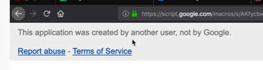

* Deploy the site (apps script site) – copy the URL
* Open visual studio code – in the iframe paste the url
* we can deploy our server or
* use site.google.com

## #Materialize CSS Chips - Google Apps Script Web App Tutorial - Part 12 14:48

* Code not updated

## #HTML Table from Spreadsheet Data - Google Apps Script Web App Tutorial - Part 13 25:46

### home.html

<!DOCTYPE html>

<!--  -->

<html>

  <head>

    <base target="_top">

      <meta name="viewport" content="width=device-width, initial-scale=1.0"/>

      <link href="https://fonts.googleapis.com/icon?family=Material+Icons" rel="stylesheet">

      <link rel="stylesheet" href="https://cdnjs.cloudflare.com/ajax/libs/materialize/1.0.0/css/materialize.min.css">

    <?!= include("page-css"); ?>

  </head>

  <body>

    <div class="container">

      <div class="row">

         <div class="input-field col s12">

           <h1>Weolcome!</h1>

            <a href="<?= ScriptApp.getService().getUrl(); ?>?v=form" id=btnSubmit class="waves-effect waves-light btn"><i class="material-icons left">cloud</i>Add Recordt</a>

            <a href="<?= ScriptApp.getService().getUrl(); ?>?v=table" id=btnTable class="waves-effect waves-light btn"><i class="material-icons left">cloud</i>Show Table</a>

               <div class="row">

      </div>  <!-- close row  -->

    </div>  <!-- close container  -->

   <script src="https://cdnjs.cloudflare.com/ajax/libs/materialize/1.0.0/js/materialize.min.js"></script>

  </body>

</html>

### table.html

<!DOCTYPE html>

<!--  -->

<html>

  <head>

    <base target="_top">

      <meta name="viewport" content="width=device-width, initial-scale=1.0"/>

      <link href="https://fonts.googleapis.com/icon?family=Material+Icons" rel="stylesheet">

      <link rel="stylesheet" href="https://cdnjs.cloudflare.com/ajax/libs/materialize/1.0.0/css/materialize.min.css">

    <?!= include("table-css"); ?>

  </head>

  <body>

    <div class="container">

      <div class="row">

        <div class="col s6">

           <table id="table-body">

        <thead>

          <tr>

              <th>Name</th>

              <th>Item Name</th>

              <th>Item Price</th>

          </tr>

        </thead>

        <tbody>

        </tbody>

      </table>

        </div>

      </div> <!--  CLOSE ROW -->

   </div>  <!-- close container  -->

    <script src="https://cdnjs.cloudflare.com/ajax/libs/materialize/1.0.0/js/materialize.min.js"></script>

    <?!= include("table-js"); ?>

  </body>

</html>

### table-js.html

<script>

  var data1 = [

    [1,"jack",55],

    [2,"back",45],

    [3,"cack",35]

  ];

document.addEventListener("DOMContentLoaded",function(){

  google.script.run.withSuccessHandler(generateTable).getTableData();

  generateTable(data);

})

  function generateTable(dataArray){

      var tbody = document.getElementById("table-body");

      dataArray.forEach(function(r){

    var row = document.createElement("tr");

    var col1 = document.createElement("td");

    col1.textContent = r[0] //"Apple";

    var col2 = document.createElement("td");

    col2.textContent = r[1] //"33";

    var col3 = document.createElement("td");

    col3.textContent = r[2] //"44";

    row.appendChild(col1);

    row.appendChild(col2);

    row.appendChild(col3);

    tbody.appendChild(row);

  });

  }

</script>

## Send Personalized Email Confirmation - Google Apps Script Web App Tutorial - Part 14 17:29

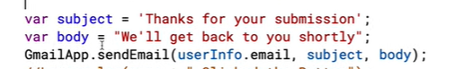

# Google Forms Tutorial For Beginners

# Google Sheets Intermediate Tutorials

<https://www.youtube.com/watch?v=0yMOMSBENbo&list=PLv9Pf9aNgemtP-BeFvg78PJFxKs6xDgea&index=1>

1

14:54

NOW PLAYING

Google Sheets IMPORTRANGE Function Tutorial - Learn How to Pull Data From Other SpreadSheets

Learn Google Spreadsheets

2

20:18

NOW PLAYING

Google Sheets - Named Ranges, Dynamic Updates, with IMPORTRANGE, Other Sheets, Arrays - Tutorial

Learn Google Spreadsheets

3

32:56

NOW PLAYING

Google Sheets Charts / Graphs Tutorial

Learn Google Spreadsheets

4

12:09

NOW PLAYING

Google Sheets - SUMIFS, SUM Functions Intro Tutorial

Learn Google Spreadsheets

▶

14:45

NOW PLAYING

Google Sheets - Drop Down List, 2 Dependent Dropdown Lists

Learn Google Spreadsheets

6

8:56

NOW PLAYING

Google Sheets - Conditional Formatting Row Tutorial

Learn Google Spreadsheets

7

15:39

NOW PLAYING

Google Sheets - Conditional Formatting Based on Another Cell Using Formulas Tutorial

Learn Google Spreadsheets

8

35:56

NOW PLAYING

Google Sheets - Pivot Tables Tutorial - includes Grouping by Date using Year, Month Functions

Learn Google Spreadsheets

# Google Sheets Advanced Tutorials

# How to Make a Chart in Google Sheets

# INDEX & MATCH - Google Sheets Tutorials

# Google Sheets Google Sheets - UserForm Web App using HTML5 & Bootstrap 4

# %Google Sheets User Interface (UI) Apps Script Series

## #Add Custom Menu - Google Sheets User Interface (UI) Apps Script Series Part 1 16:00

project created AP_GD

## #Message Box Alerts, Yes/No Confirmation Box - Google Sheets UI Part 2 11:22

## ???Google Sheets - Input Box (Prompt) - User Interface (UI) Part 3 18:38 check one more time

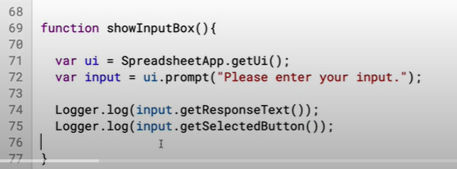

# %Google Sheet Scripts Playlist - getto@gmail – SamplePrj do all this and delete the screenshots

<https://www.youtube.com/watch?v=aPJ-2U45BpA&list=PLv9Pf9aNgemv62NNC5bXLR0CzeaIj5bcw>

## App Script Editor Tutorial - Google Sheets - Excel VBA Equivalent - Read & Write to Ranges & Cells 29:48

Gsheet – Extension Menu – Apps Script

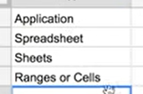

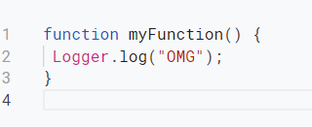

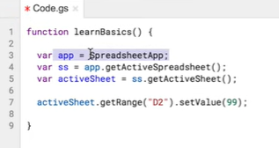

getrange works for range and cell

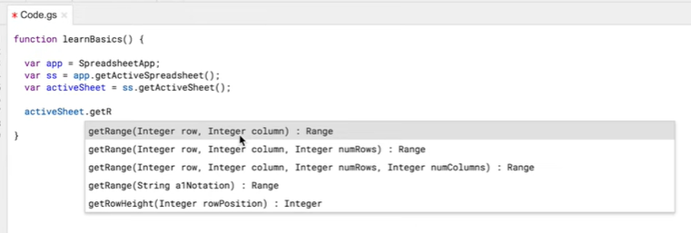







Reading data





## App Script Tutorial - Google Sheets - For Loops, Looping Through Cells, Variables, Comments - Part 2 24:17”

??? how gsheet knows starting function?

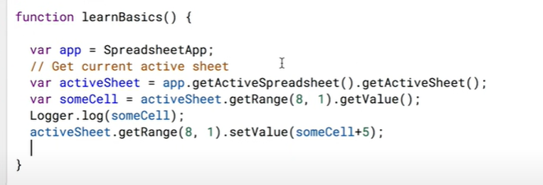

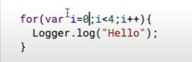



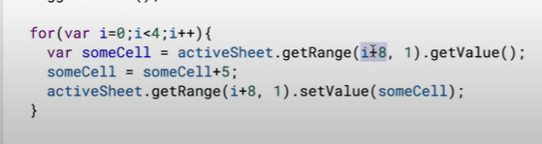

## Google Sheets Scripts Tutorial - Get & Set Cell Value in Other Sheets - Part 3 10:05

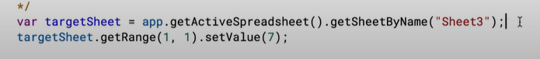

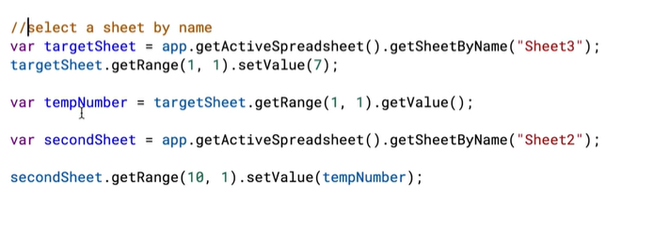

## Google Sheets Apps Script Tutorial - Clear Contents - Part 4 5:49

clear = clear the data and format

clearcontent = clears only content – format will be reamins

clearformat = clear only format

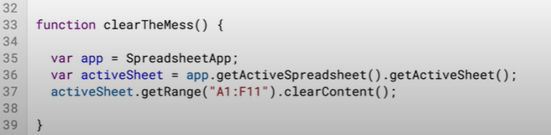

we can choose which function to be run

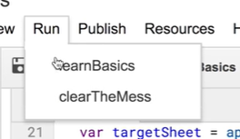

## Google Sheets - Create Custom Functions (UDF) using Apps Script with AutoComplete Tutorial - Part 5 11:40

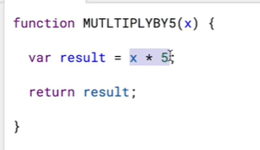

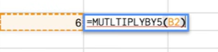

the below /** will enable the autocomplete in gsheet

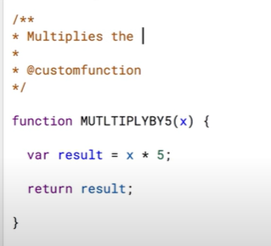

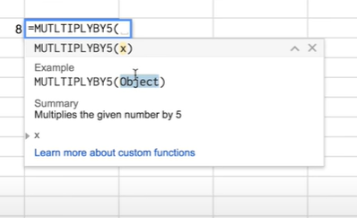

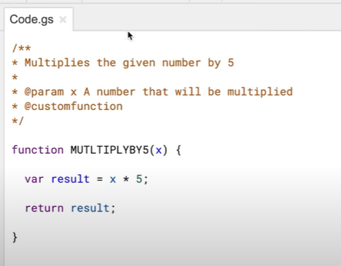

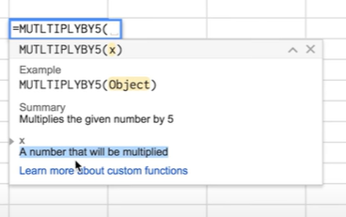

## Google Sheets Apps Script - If, Then, Else If, Else JavaScript Statements Tutorial - Part 6 17:43

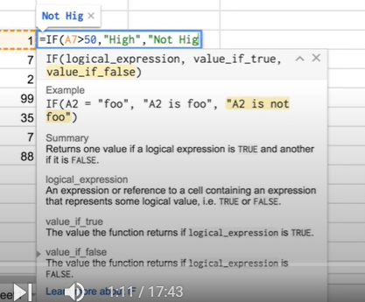

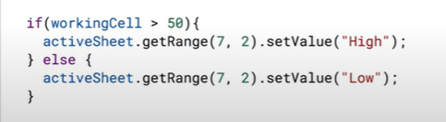

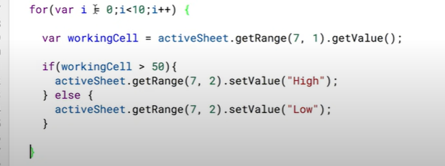

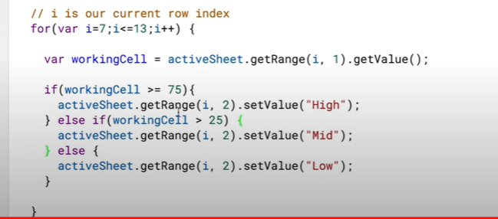

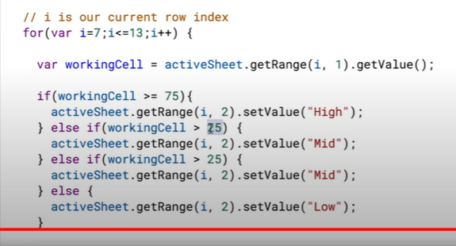

## Google Sheets Apps Script - Read Range to a JavaScript Array & Write to a Range Tutorial - Part 7 10:21

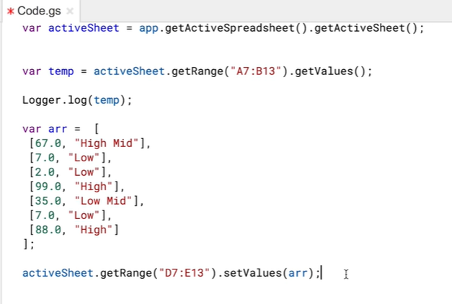

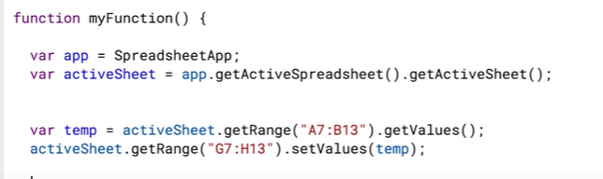

/*

multi line comments here

*/

## Google Sheets - Apps Script New Authorization Steps 2017 Tutorial - Part 8 2:46

## Google Sheets - Apps Script Fill Down Formula (Set a Fromula & Copy Down AutoFill) Tutorial - Part 9 11:52

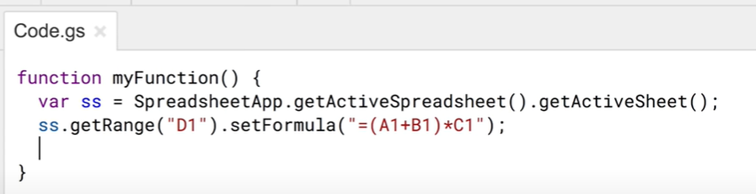

Copy formula

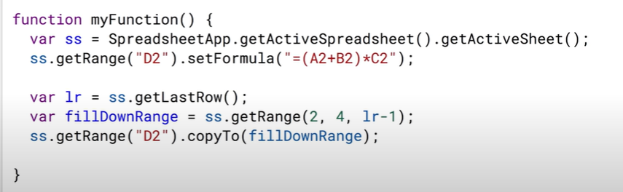

## Google Sheets - Apps Script Google Calendar API Integration Tutorial - Get Events - Part 10 30:52

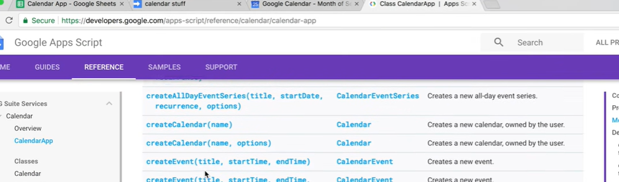

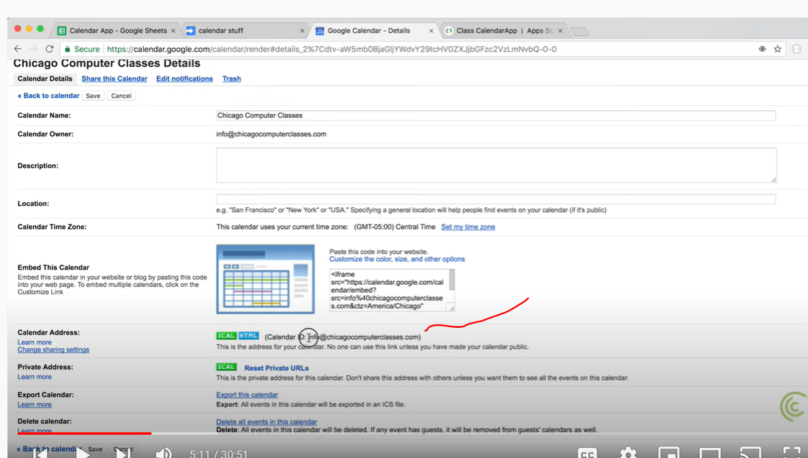

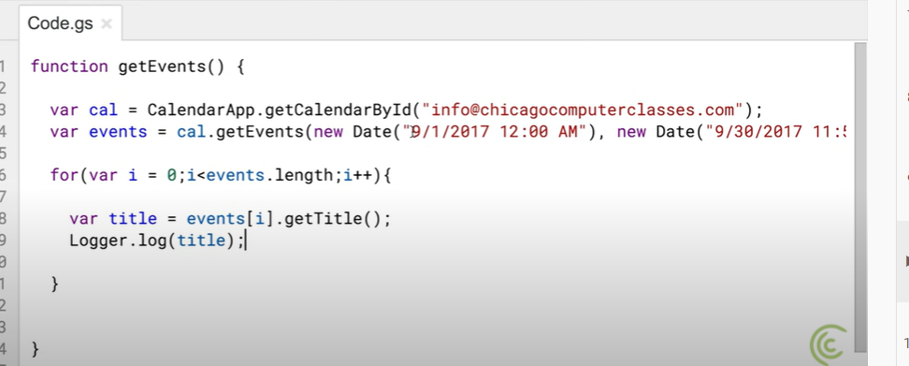

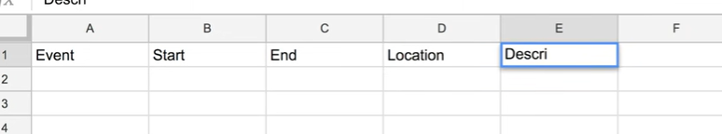

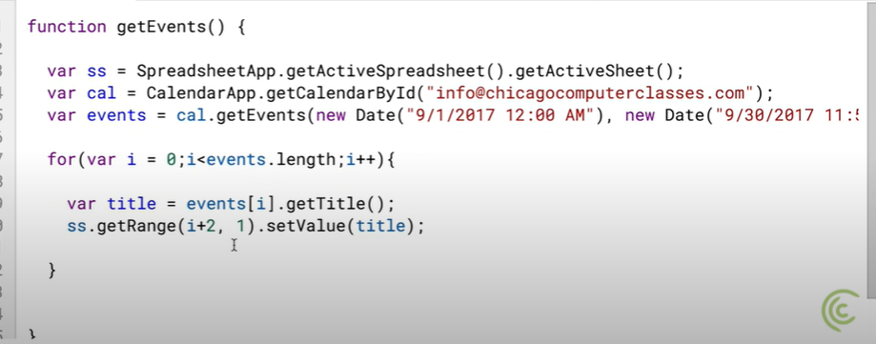

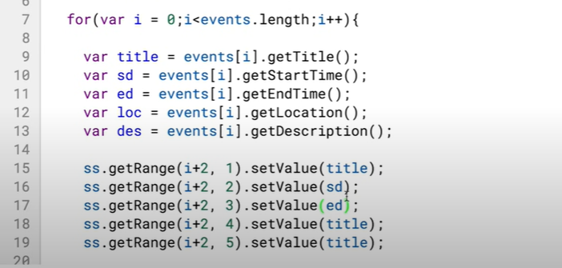

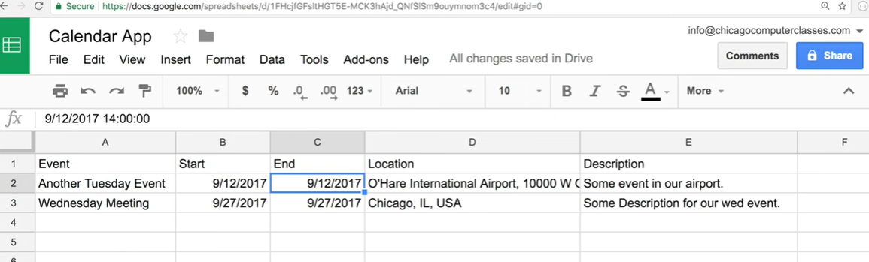

## Google Sheets - Add (Import) Events in Bulk to Google Calendar Using Apps Script Tutorial - Part 11 19:25

## Google Sheets - Send Emails Using Apps Script JavaScript MailApp Tutorial - Part 12 36:10

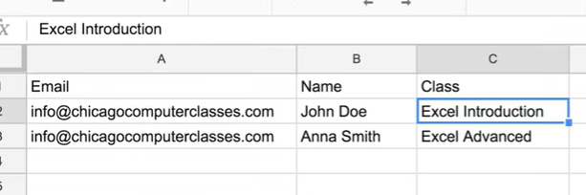

email tempalte

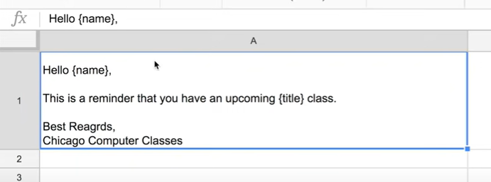

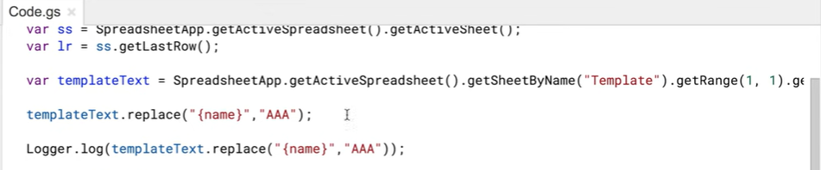





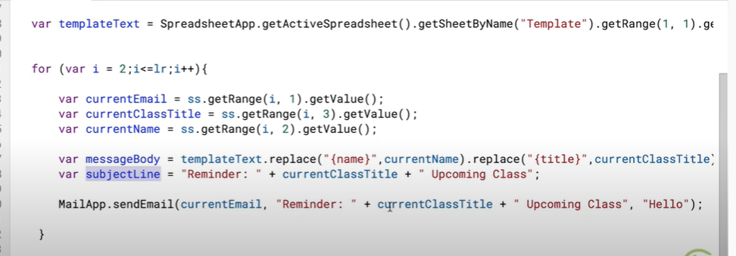

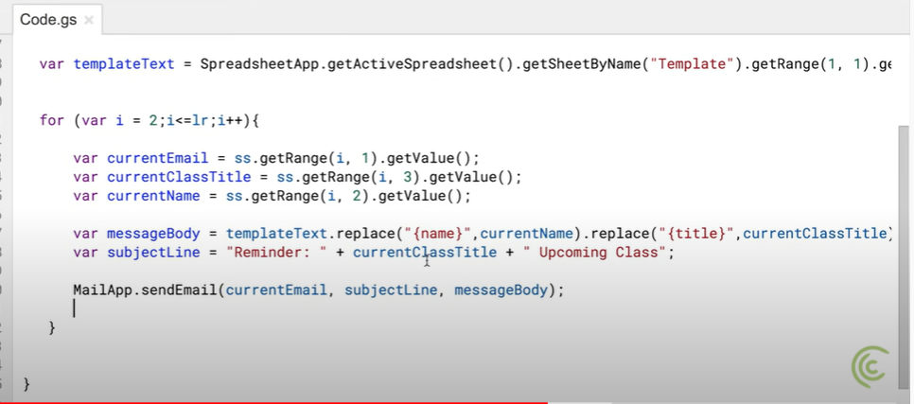

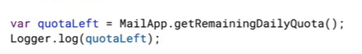

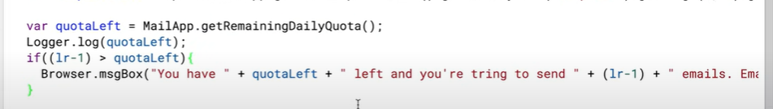

## *JavaScript Objects - Iterate Through Object Keys and Values - Google Sheets Apps Script - Part 13 35:10

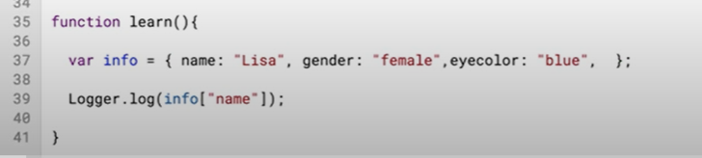

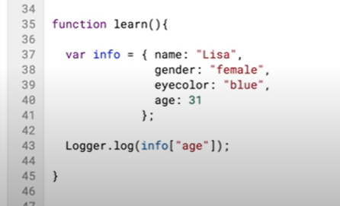

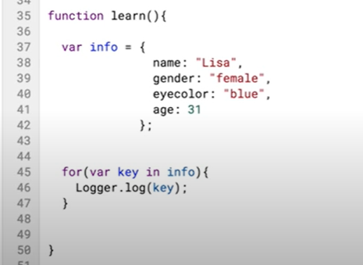

now key and val both will be logged

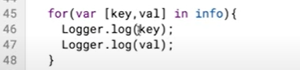

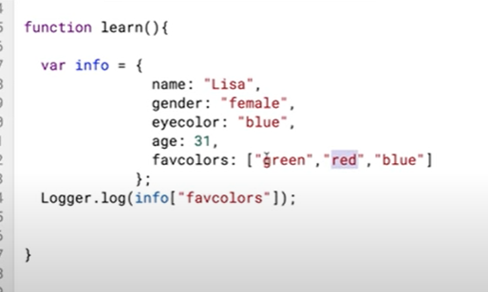

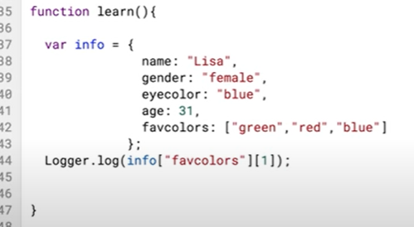

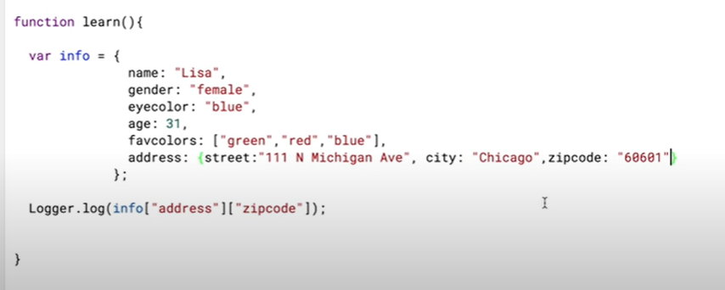

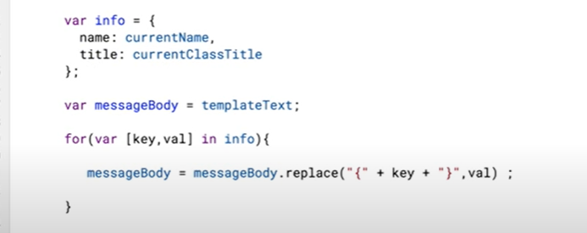

## Google Maps Distance & Duration Calculator - Google Sheets, Build Apps Script Function - Part 14 42:34 - skipped

## Google Apps Script - Google Drive Tutorial, Files, Folders, Copy Files, DriveApp, Iterator - Part 15 29:31

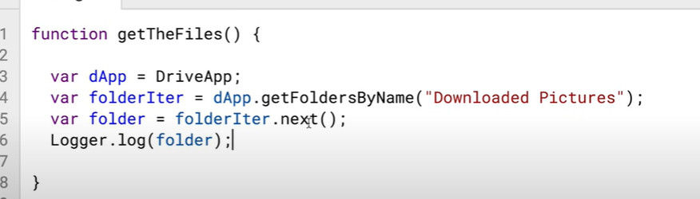

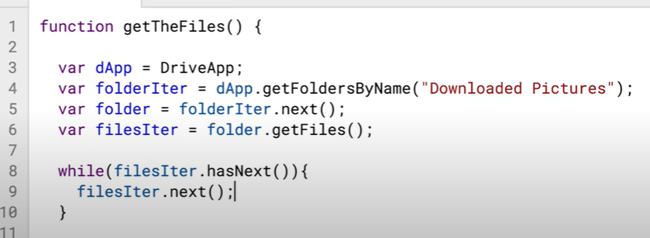

## Match Function with Google Sheets Apps Script -JavaScript IndexOf Method Tutorial - Part 16 18:48

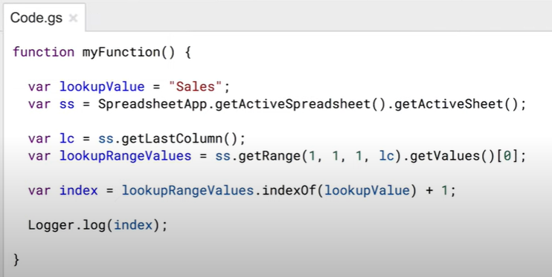

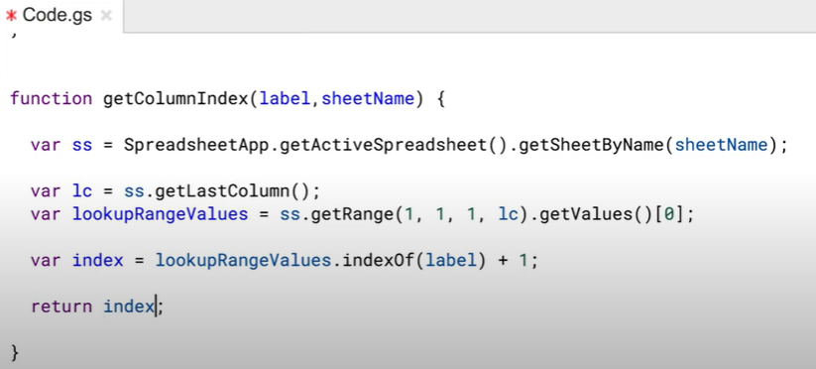

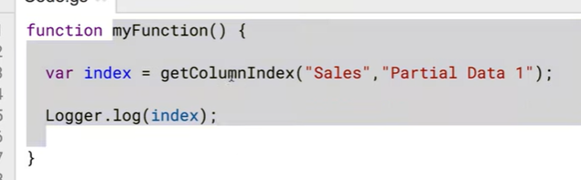

## ???Google Sheets - Combine All Sheets into One When Column Order Doesn't Match - Apps Script - Part 17 40:47

Get the script <https://www.chicagocomputerclasses.com/google-sheets-apps-script-combine-multiple-tabs-to-a-master-tab-when-column-positions-dont-match/> and practice

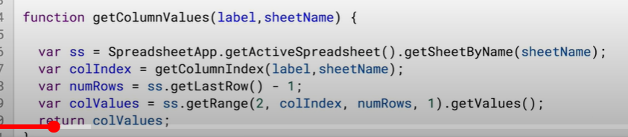

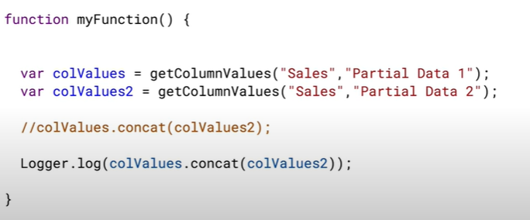

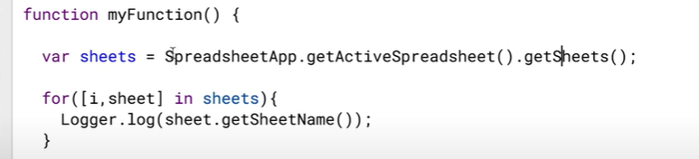

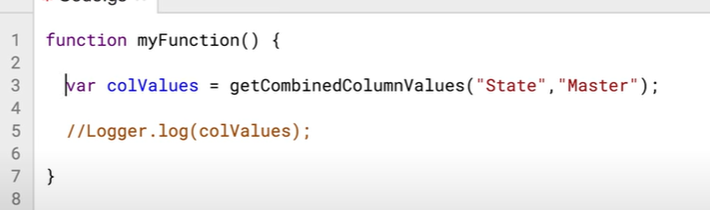

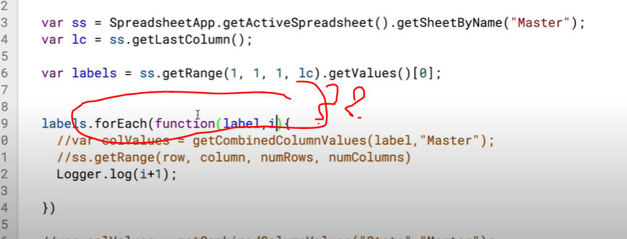

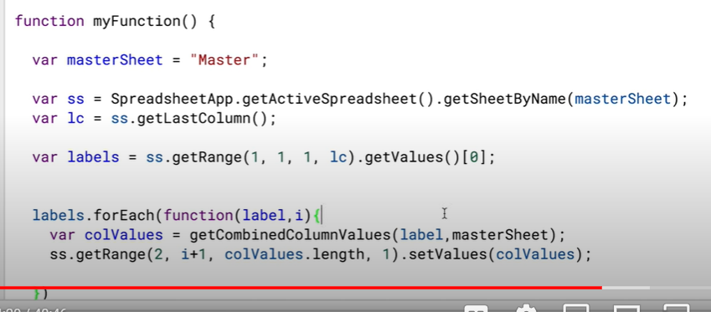

Before start clear the content



## #Google Sheets - Dependent Dropdown List for Entire Column - App Scipt, Run On User Input - Part 1 19:33

Ctrol Shift Down Arrow – to block cells

functionb onEdit() – event tracking function

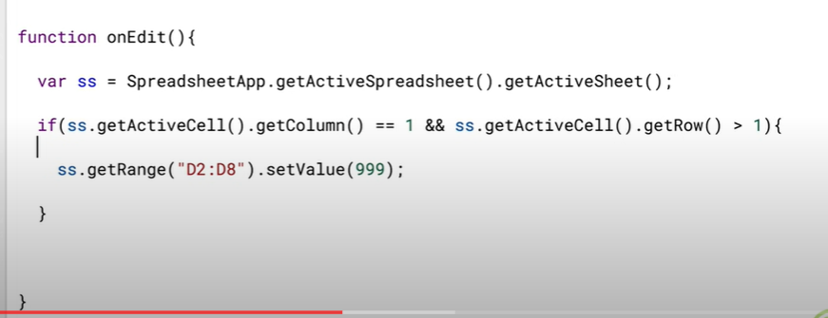

## #Google Sheets - Dependent Dropdown List for Entire Column - Apps Scipt, Match Alternative - Part 2 24:14

<https://www.chicagocomputerclasses.com/google-sheets-apps-script-dynamic-dependent-dropdown-data-validation-lists/>

## ???Google Sheets - Crosstab to List or Flat File Data Table, UnPivot - Apps Script Tutorial 21:53

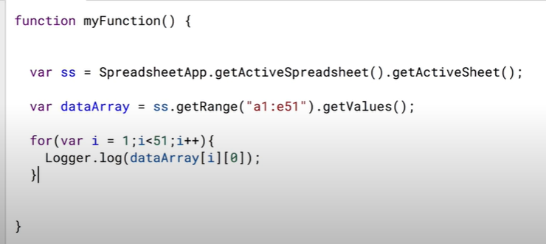

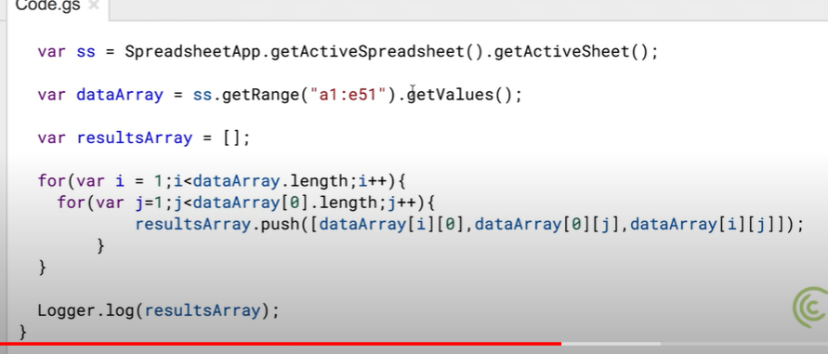

## Google Sheets - Macro Recorder Tutorial - How to Record an Apps Script 20:52

Absolute reference Macro OR

Relative Reference Macro